Dennis Joe Eyanson
February 20, 1954 – October 25, 2024

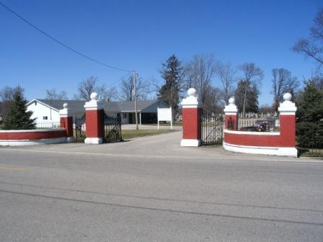
Photo by Barbara Baker Anderson

Dennis J. "Joe" Eyanson, 70, of Decatur, Indiana passed away on Friday, October 25, 2024, at Celebrate Senior Living in Fort Wayne, Indiana. He was born on February 20, 1954, in Decatur, Indiana to the late Robert P. and Wanda J. (Garner) Eyanson. He was united in marriage to Linda K. Peterson and she preceded him in death on December 16, 1998.
Joe attended Bellmont High School and retired from Bunge in Decatur where he worked in the receiving department. Joe loved playing horseshoes and ping pong. He enjoyed fishing and played wiffle ball in Wren, Ohio.
Survivors include two brothers, James Eyanson of Celina, Ohio and Edward Eyanson and Seale, Alabama; three sisters, Deana "Sue" Pickens of Geneva, Indiana, Angela (Dan) Davis of Bluffton, Indiana and Rebecca (Richard) Wible Jr. of Decatur, Indiana; step-son, John Cerna of Monroe, Indiana; step-daughter, Tessa White of Decatur, Indiana; two granddaughters, Haylee and Elizabeth " Lizzy" Eyanson; several nieces and nephews; many wonderful friends including his faithful canine companion, Charlie.
He was preceded in death by a son, Aaron Eyanson; two sisters, Cheryl Pietosi and Janet Rhodes; and brother, Larry "Tom" Eyanson.
A funeral service will be held at 10:30 a.m. Thursday, October 31, 2024, at Zwick & Jahn Funeral Home in Decatur with Pastor Ernie Suman officiating. Burial will follow in the Decatur Cemetery. Family and friends will be received from 5-8 p.m. Wednesday, October 30, 2024, at Zwick & Jahn Funeral Home in Decatur and one hour prior to the service on Thursday at the funeral home.
Preferred memorials are to the Huntington's Disease Society of America.

Zwick and Jahn Funeral Homes, Adams County, Indiana
October 30, 2024

