Arron M. Eyanson
November 16, 1974 - September 8, 2015

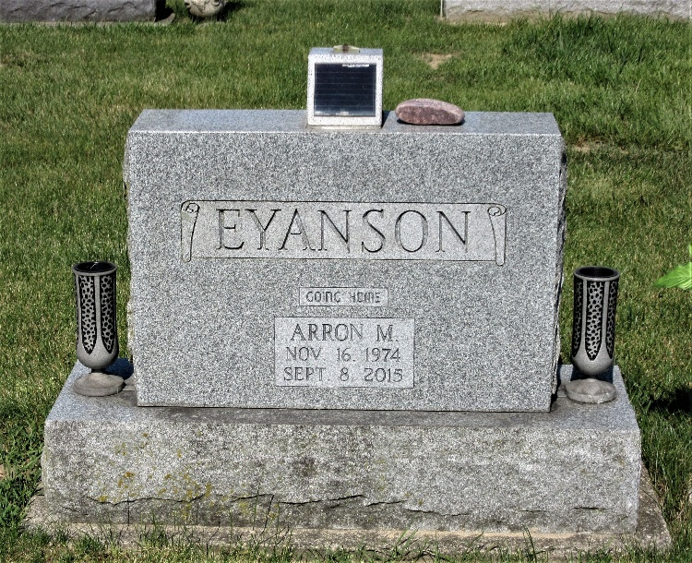
Photo by PLS

Arron M. Eyanson, 40 years old of Decatur, Indiana, passed away on Tuesday, September 8, 2015 at his residence. He was born on Saturday, November 16, 1974 in Decatur, Indiana the son of Dennis & Linda (Peterson) Eyanson. His mother preceded him in death.
Arron attended Mt. Victory United Brethren Church and had previously attended Decatur Church of God and The Bridge Community Church. He had previously worked at Prestress in Decatur and All American Homes in Decatur.
Surviving are two daughters, Haylee Eyanson and Elizabeth "Lizzie" Eyanson, both of Decatur and his father, Dennis "Joe" Eyanson of Decatur.
Preceding Arron in death were his maternal grandparents, Karl Richard & Ilene (Mitchel) Peterson and paternal grandparents, Robert and Wanda (Garner) Eyanson.
A memorial service will be held at 10:30 a.m. Saturday, September 12, 2015 in the Zwick & Jahn Funeral Home in Decatur. Family and friends will be received from 9 a.m. until the time of service on Saturday at the funeral home.
Preferred memorials are to Huntington's Disease Society of America or the donor's choice.

Zwick & Jahn Funeral Home, Adams County, Indiana
September 9, 2015

