Janet L. (Seitz) Evans
March 18, 1933 – April 8, 2025

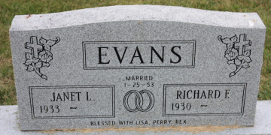
Photo by Alicia Kneuss

Janet L. Evans, 92, of Decatur, IN, passed away Tuesday, April 8, 2025 at Adams Woodcrest. Janet was born on March 18, 1933 in Columbus Grove, Ohio to the late Charles E. and Beulah M. (Wood) Seitz. On January 25, 1953, Janet married Richard E. "Dick" Evans. He preceded her in death on April 5, 2021.
Janet was a member of Grace First Community Church in Decatur. She retired as a payroll supervisor at C.T.S. in Berne. Janet loved music. She was in multiple musicals in the Decatur Theater program; she sang with the Men's Four gospel group and The Second Mile Singers. She sang at church her whole life. Janet enjoyed traveling especially our family vacations to Ocracoke Island, North Carolina.
Janet is survived by 2 sons, Perry D. (Kelly) Evans of Middle Point, Ohio, Rex L. (Nancy) Evans of Decatur, Indiana; daughter, Lisa A. Steffen of Decatur, Indiana; 9 grandchildren and 21 great grandchildren.
She was preceded in death by 3 brothers, Winston W. Seitz, Vernon D. Seitz and Raymond Seitz; 2 sisters, Winifred J. Seitz and Carol S. Aurand.
Visitation will be on Tuesday, April 15, 2025, from 9:30 – 11:00 a.m. at Woodcrest Porter Auditorium, followed by a 11:00 a.m. funeral service. Karen Garner officiating and burial will follow in Decatur Cemetery.
Preferred memorials are to Indiana Chapter of the Cystic Fibrosis Foundation on behalf of Janet's great-grandchild, Brynn Magner. Make checks payable to Cystic Fibrosis Foundation with the following in the memo line: Brynn's Brigade/Janet Evans.

Haggard Hirschy & Zelt Funeral Home, Adams County, Indiana
Apr. 9, 2025

