Helen Elizabeth (Weber) Erxleben
January 24, 1915 – September 17, 2007

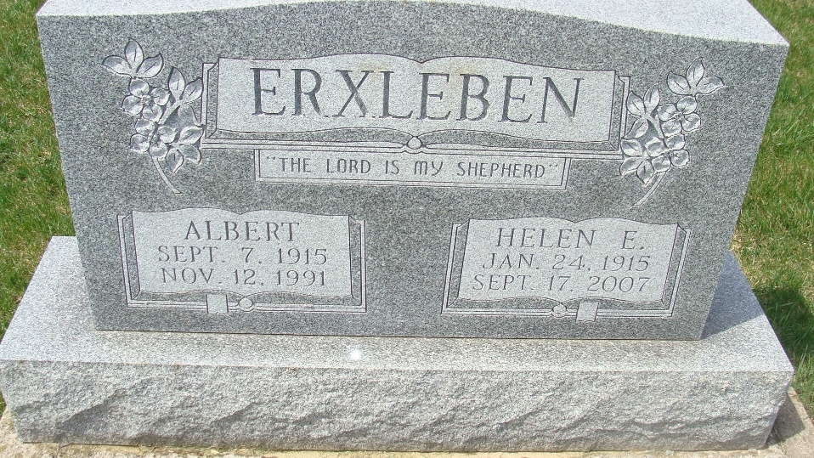
Photo by Alicia Kneuss
Helen E. Erxleben, 92 years old of rural Decatur, Indiana, passed away at 4:45 p.m. on Monday, September 17, 2007 at her residence.
Helen was born on Sunday, January 24, 1915 in Adams County, Indiana, the daughter of the late William Weber and the late Sophia (Bieberich)Weber. She married the late Albert Erxleben on August 27, 1949 in St. Paul Lutheran Church, Preble, and he passed away on November 12, 1991. Helen was a member of Zion Lutheran Church, Friedheim and was a homemaker.
Surviving are her son, Donald (Joy) Erxleben of Decatur, Indiana; daughter, Carol Ann (Michael) Selking of Decatur, Indiana; sister, Mildred Bleeke of Decatur, Indiana; eight grandchildren: Lisa (Chris) Bills; Brian Erxleben; Kellie (Nick) Hartman; Amy Erxleben; April Erxleben; Krista (Brock) Roseberry; Jamie Selking; Megan Selking; and two great-grandchildren: Thomas Bills, Peyton Erxleben.
Preceding Helen in death were one son, Ronald Erxleben and several brothers and sisters.
Funeral services for Helen will held at 11:00 a.m. on Friday, September 28, 2007 in the Zion Lutheran Church, Friedheim with Pastor Daniel Dahling officiating. Friends and family will be received on Thursday, September 27 from 4-8 p.m. in the Zwick & Jahn Funeral Home, Decatur.
Preferred memorials are to Zion Lutheran Church, Friedheim; Family Hospice of N E Indiana; or Donor's Choice.

Zwick & Jahn Funeral Home, Adams County, Indiana
**

Indiana, Death Certificates, 1899-2011
Name: Helen E Erxleben
[Helen E Weber]
Gender: Female
Race: White
Age: 92
Marital status: Widowed
Birth Date: 24 Jan 1915
Birth Place: Adams County, In
Death Date: 17 Sep 2007
Death Place: Decatur, Adams, Indiana, USA
Father: William Weber
Mother: Sophia Bieberich
Informant: Don Erxleben; don; Decatur, Indiana
Burial: September 21, 2007; Zion Lutheran Cemtery Friedheim; Decatur, Indiana

Note: Confirmation came from Decatur Cemetery that Helen is buried in Decatur Cemetery

