Gary Benbow Erekson
August 28, 1933 – February 20, 2024

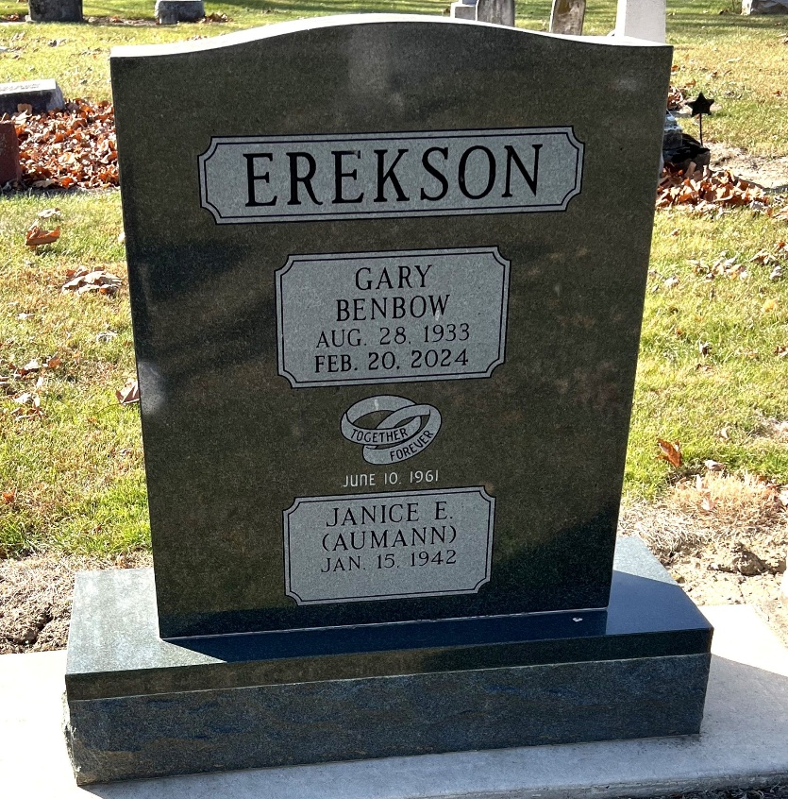
Photo by Deb Curry

Gary Benbow Erekson, 90, passed away peacefully in his sleep on Tuesday, February 20, 2024, at Center for Hospice Care in Elkhart, IN.
Gary was born on August 28, 1933, in Murray, Utah, to Reid Benbow & Evelyn (Olson) Erekson.
He is survived by Janice (Aumann) Erekson, his wife of 62 years, and his sister and brother-in-law, Taya & John Cowan of Ft. Wayne, IN and his sisters-in-law Carolyn Brown and Judith Light. He is also survived by his sons and daughters-in-law Cameron & Audrey Erekson of Broomfield, CO, Craig Erekson of Bristol, IN, and Christopher & Joanna Erekson of Middlebury, IN.
Surviving grandchildren (9) & great-grandchildren (5) include Spencer (Brittany) Erekson and their children, Reagan, Simon, and Landon, of Superior, CO, Reid (Anisha) Erekson of Arlington Heights, IL, Olivia Erekson and her fiancée Arick Doberenz of Middlebury, IN, Emily & Colin Utley and their children, Beau & Louie, of Middlebury, IN, Lt. William Erekson, USCG, Sophie Erekson of Bristol, IN, Jackson Erekson, Charlie Erekson, and Luke Erekson of Middlebury, IN.
In addition to his parents and in-laws, Norbert and Hilda Aumann.
Gary was predeceased by his sisters, Sandra Mutchler and Greta Schnepf.
Gary’s family moved quite often and were involved in local theater and radio productions wherever they settled. He graduated from Decatur (Indiana) High School in 1951 where he played basketball, football, and baseball. After high school, he attended the US Coast Guard Academy in New London, CT where he finished 2nd in his class, captained the varsity basketball team for two years, and was battalion commander for his class. Gary graduated as a commissioned officer in 1955 and was stationed in Miami and Miyako Jima. Gary left the Coast Guard in 1959 to attend Harvard University where he received his MBA in 1961.
He met and began dating the light of his life, Janice Aumann, during his time at Harvard and they married on June 10, 1961 settling in Decatur, IN, where he began his 27-year career with CTS Corporation. CTS took him from CTS of Berne (IN), to a sales office in Pasadena, CA, West Lafayette, IN and back to Berne, where he was eventually named President of CTS of Berne. In 1984 Gary, Jan and the boys moved to Elkhart, IN after Gary was named chief operating officer of CTS Corporation and transferred to corporate head-quarters. He retired from CTS as chief financial officer in 1988.
Gary enjoyed the 30 winters that he and Janice spent in Marco Island, FL. They always had plenty of family visitors and made many memories there.
Gary loved to compete; he was up for just about any game or contest at any time. He was an excellent bridge and chess player. Gary loved playing basketball on the driveway with his boys. He also enjoyed golf and tennis and played until well into his 80’s when his back told him it was time to retire his clubs and racquet.
Gary will be remembered by his friends and family as a wonderful husband, father and son. He had a very quick wit and enjoyed making people smile.
Family and friends will be received from 1-3 p.m. on Saturday, February 24, 2024 at the Zwick& Jahn Funeral Home, Decatur. Private family services will be held at a later date with burial at Decatur Cemetery.
In lieu of flowers, memorials may be made to Center for Hospice Care, 501 Comfort Place, Mishawaka, IN 46545 or Zion Lutheran Church, 1010 W. Monroe St, Decatur, IN 46733.

Zwick & Jahn Funeral Home, Adams County, Indiana
February 20, 2024

