Gladys Olive (Springer) Engle
August 20, 1892 – July 14, 1956

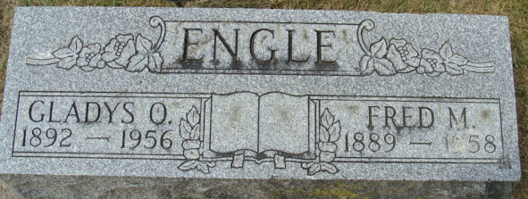
Photo by Alicia Kneuss

Mrs. Gladys Engle Is Taken By Death
Funeral Services Tuesday Afternoon
Mrs. Gladys O. Engle, 64, wife of Fred Engle, 219 Ragg Street, died at 11:15 o’clock Saturday night at the Adams County Memorial Hospital following an illness since last November, of cancer.
She was born in Van Wert County, O., Aug. 20, 1891, a daughter of Louis and Esther Matthews-Springer, and was married to Fred Engle Sept. 6, 1909.
Mrs. Engle was a member of the Bethany Evangelical United Brethren Church and was a charter member of the Women of the Moose.
Surviving in addition to the husband are one son, Richard Engle of Kendallville; one daughter, Mrs. Mary Bundrick of Berwyn, Ill.; two brothers, Charles Springer of Bryant and Virgil Springer of Lima, O.; three sisters, Mrs. Floyd Acker of Decatur, Mrs. Dove Hauck of Lima, O., and Mrs. Velma Smith of Eugene, Ore. One sister is deceased.
Funeral services will be held at 1:30 p.m. Tuesday at the Black Funeral Home and at 2 p.m. at the Bethany Evangelical United Brethren Church, the Rev. Lawrence T. Norris officiating. Burial will be in the Decatur Cemetery. Friends may call at the funeral home until time of the services. There will be no viewing at the church.
Decatur Daily Democrat, Adams County, Indiana
Monday, July 16, 1956

