William Roscoe Elzey
October 30, 1880 – August 23, 1953

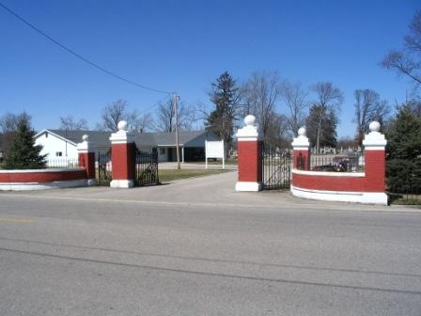
Photo by Barbara Baker Anderson

Indiana, U.S., Death Certificates, 1899-2017
Name William Roscoe Elzey
Gender Male
Race White
Marital Status Married
Age 72 y 9m 23d
Birth Date 30 Oct 1880
Birth Place Adams County, Indiana
Death Date 23 Aug 1953
Death Place Decatur, Adams, Indiana, USA
Death Registration Date 1953
Father Richard S Elzey
Mother Delphans Fisher
Informant Mrs. W. R. Elzey, Decatur, Ind.
Burial 8/26/1953 Decatur Cemetery

