James Allen Elliott
November 15, 1943 – September 13, 2024

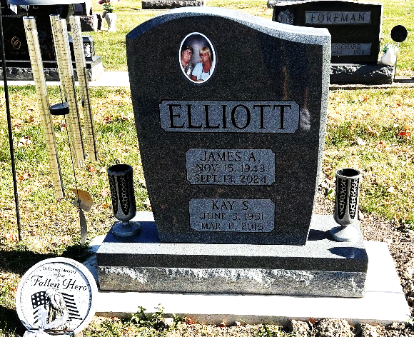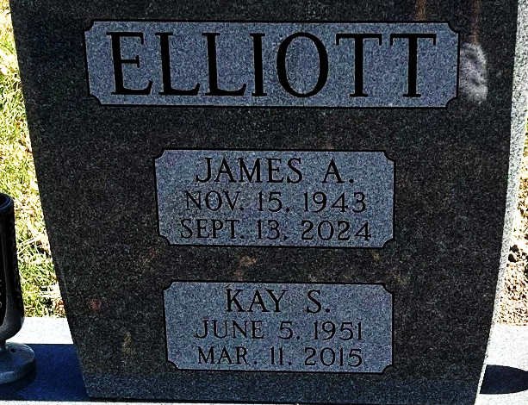
Photo by Deb Curry

James Allen Elliott, 80, of New Haven, Indiana, passed away on Friday evening, September 13, 2024, at Parkview Regional Medical Center in Fort Wayne, Indiana. He was born on November 15, 1943, in Decatur, Indiana to the late Carl and Mildred (Johnson) Elliott. Jim married Kay Edgar in Waynedale, Indiana, on June 23, 1979. She preceded him in death on March 11, 2015.
Jim served his country in the United States Army during the Vietnam War. He was a 1962 graduate of Decatur High School. Jim was employed by Kroger in Fort Wayne for over 38 years in the warehouse and was formerly employed at Decatur Industries.
He was a member of the American Legion Post #223 in Syracuse, Indiana. Jim enjoyed golfing, fishing, and bowling. He also loved walking on the beaches.
He is survived by his son, James Allen Sidle of Van Wert, Ohio; son, Bill (Cheryl) Bosch of Decatur, Indiana; son, Guy Vaice of Roberstsdale, Alabama; sister, Phyllis Brunner of Decatur, Indiana; brother, Max (Linda) Elliott of Fort Wayne, Indiana; sister, Beverly Riley of Marion, Indiana; sister-in-law, Susan Elliott of Decatur, Indiana; four grandchildren, Trista Bosch, Maci Bosch, Derek Loshe, and Austin Dabbs; and eight great-grandchildren, Phoenix Lengerich, Flint Lengerich, Reese Loshe, Canaan Loshe, Blake Loshe, Jasper Hough, Jaxxon Loshe, and Amaya Dabbs.
He was preceded in death by his twin sister, Jane Elliott (in infancy); sister, Helen McDonald; and two brothers, Carl and Jack Elliott.
A Celebration of Life will be held for Jim and Kay at 10:00 a.m. Friday, September 27, 2024, at the Zwick & Jahn Funeral Home in Decatur, Indiana with Life Celebrant Dave McIntire officiating. Burial will follow at the Decatur Cemetery with Military Honors rendered by the American Legion Post #43.
The family will receive friends one hour prior to the service at Zwick & Jahn Funeral Home in Decatur.
Preferred memorials can be given to the Wounded Warrior Project.

Zwick & Jahn Funeral Home, Adams County, Indiana
September 19, 2024

