Timothy A. Eichhorn
April 12, 1968 – January 24, 2006

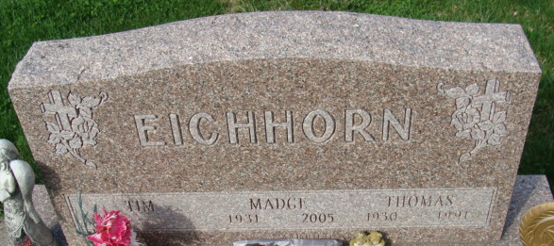
Photo by Alicia Kneuss

Timothy A. “Beak” Eichhorn, 57 of Decatur, Indiana passed away Saturday, January 24, 2026, at his residence following a heroic battle with cancer. Beak was born to Thomas F. Eichhorn and Leota Madge (Waldron) Eichhorn on April 12, 1968, in Decatur, Indiana and preceded him in death. Tim was engaged to Bonnie Stabler, who survives.
He was a longtime member of the Eagles Aerie #2653 in Decatur along with the Sons of the VFW, Post 6236 also in Decatur. Beak was a proud pipe layer…working at Geiger Excavating for over 10 years. Prior to working at Geiger’s, he was employed by Reinhart Landscaping in Decatur.
Beak was known for his ornery nature and his zest for life, often described as being “full of piss and vinegar”. He graduated from Bellmont High School, where he likely began developing his lifelong hobbies. Beak was an avid collector of all things, a passionate scrapper, and took great joy in “raising hell,” wherever he went, which brought laughter and memorable moments to those around him.
He is survived by his son, Corey A. Eichhorn of Kendallville, Indiana; fiancé, Bonnie Stabler of Decatur, Indiana; brother, Michael “Smurf” Eichhorn of Decatur, Indiana; sister, Vickie Williams of Decatur, Indiana; sister, Beth McIntyre of Decatur, Indiana.
He was preceded in death by his brother, Thomas F. Eichhorn and sisters, Amber Eichhorn and Cheryl Bauermeister.
Funeral services for Beak will be held at 12 Noon on Saturday, January 31, 2026, at the Zwick & Jahn Funeral Home in Decatur with Pastor Ernie Suman officiating, followed by burial at Decatur Cemetery. Family and friends will be received two hours prior to services at the funeral home.
Preferred memorials to the family for assistance with funeral expenses.

Zwick and Jahn Funeral Homes, Adams County, Indiana
January 27, 2026

