Robert E. Durbin
February 7, 1939 - January 25, 2026

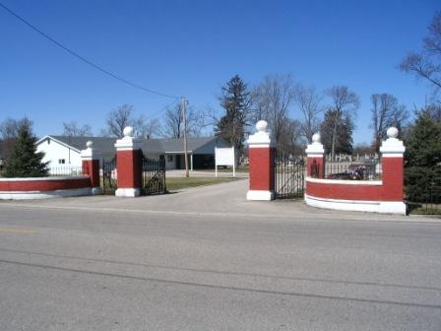
Photo by Barbara Baker Anderson

Robert E. “Bob” Durbin, 86, of Decatur, Indiana passed away Sunday evening, January 25, 2026, at Adams Woodcrest. He was born on February 7, 1939 in Decatur, Indiana to Daniel F. and Lois M. (Scrogham) Durbin. Bob was united in marriage to Rebecca J. Heyerly on February 15, 1958.
He served in the Indiana National Guard from 1957 to 1963. Bob was a longtime member of the Decatur Church of God. He was a member of the American Legion Post #43 in Decatur where he was active in the Color Guard and was a lifetime member of the Goldwing Road Riders Association. Bob also served on the Decatur Cemetery Board of Directors for many years.
He was an electrician at Berne Electric prior to owning and operating Bob’s TV in Decatur for 15 years. He retired from Micro Precision in Berne in 2004. Bob flew model airplanes and also received his private pilot’s license. Bob and Becky enjoyed traveling on their Goldwing and made it to all 48 continental states. He also enjoyed camping and boating. He was gifted at fixing and repairing anything.
He is survived by his wife, Becky Durbin of Decatur, Indiana; son, Rob (Kate) Durbin of Decatur, Indiana; son, Tony (Krista) Durbin of Ohio City, Ohio; daughter, Jenny (Mark) Gerig of Decatur, Indiana; sister, Carol Geels of Decatur, Indiana; grandchildren, Haley Durbin, Alexandra “Allie” (Darrel) Drake, Eric (Bailey) Durbin, Sarah (Brad) Rathbun, Kyle Durbin, Adrian Camp, Craig (Lexxie) Camp, Lance (Cheyenne) Camp, Kennedy Gerig and great-grandchildren, Kale, Alex & Graham Rathbun, Kira & Ezri Durbin, Leandro “Dro” Duran, Eleanor “Ellie” & Hazel Drake, and Emmy Lou Fulton.
A funeral service will be held at 10:30 a.m. on Friday, January 30, 2026, at Decatur Church of God located at 1129 Mercer Avenue in Decatur, Indiana with Pastor Brent Doster officiating. Military Honors to be conducted by the American Legion Post #43 of Decatur immediately following the service at the church. Burial will follow at Decatur Cemetery. Family and friends will be received from 2 to 7 p.m. Thursday, January 29, 2026, at Zwick & Jahn Funeral Home in Decatur and one hour prior to the service at the church on Friday.
Preferred memorials are to ACCF Robert & Rebecca Durbin Community Enrichment Fund or the Decatur Church of God.

Zwick and Jahn Funeral Homes, Adams County, Indiana
January 27, 2026

