James Andrew “Junior” DeBolt
December 6, 1920 – October 5, 1922

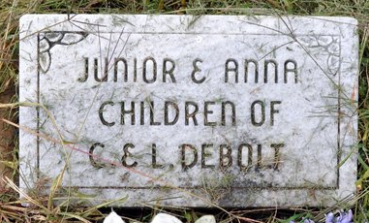
Photo by Deb Curry

Baby Died at Home of Grandmother Here

James Andrew Debolt, young son of Mr. and Mrs. Clarent Debolt, of Sturgis, Mich., died at the home of his grandmother, Mrs. William Foreman, on Line Street here, at 2 o’clock yesterday afternoon. Death was due to summer complaint.
The baby was born on December 6, 1920. The child and his parents have been visiting here for a few days.
No funeral arrangements have been made.

Decatur Daily Democrat, Adams County, Indiana,
Friday, October 6, 1922
**
Indiana, U.S., Death Certificates, 1899-2017
Name James Andrew Debolt
Gender Male; Race White
Marital Status Single; Age 1
Birth Date 6 Dec 1920; Birth Place Decatur, Indiana
Death Date 5 Oct 1922; Death Place Decatur, Adams, Indiana, USA
Death Registration Date 1922
Father Clarent Debolt
Mother Leota Forman
Informant Clarent Debolt; Decatur, Indiana
Burial October 7, 1922; Decatur Cemetery

