Mary Katherine (Shackley) Davis
April 24, 1907 – February 1, 1948

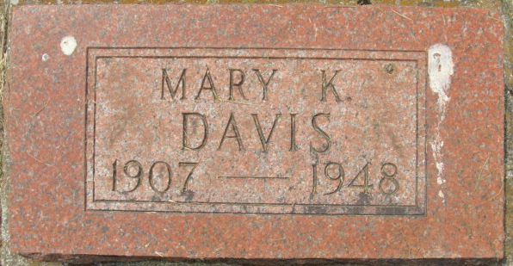
Photo by Alicia Kneuss

FORMER BERNE RESIDENT DIES
Rites at Decatur Wednesday for Mrs. Mary Katherine Davis

Funeral services for Mrs. Mary Katherine Shackley Davis, 40, of 721 West Jefferson Street, Fort Wayne, formerly of Berne and Decatur, will be held at 2 p.m. Wednesday at the Black Funeral Home in Decatur. The Rev. C. J. Robert, of Lafayette, will officiate and burial will be in the Decatur Cemetery.
Mrs. Davis died at 1 a.m. Sunday at St. Joseph's Hospital in Fort Wayne. She lived here with her parents in her youth and moved from here to Decatur.
Mrs. Davis had been ill for two weeks. Death was attributed to heart disease.
Surviving is a daughter, Mrs. Eileen Klick, Fort Wayne; a son, Pfc. Richard Young, with the U. S. Air Force at Biloxi, Miss.; a sister, Miss Ireta Shackley, Fort Wayne, and four brothers, Glen of Ft. Wayne, Lloyd and Raymond, both of Decatur, and Earl, Van Wert, Ohio.

Berne Witness; Adams County, Indiana
Monday, February 2, 1948

**
Indiana, U.S., WPA Birth Index, 1880-1920
Name Shackley
Gender Female
Birth Date 24 Apr 1907
Birth Place Adams, Indiana, USA
Father Wm Shackley
Mother Carrie Elzey
Book H-9
Page 19

