Ilene (Shaffer) Dailey
April 3, 1934 – January 14, 2024

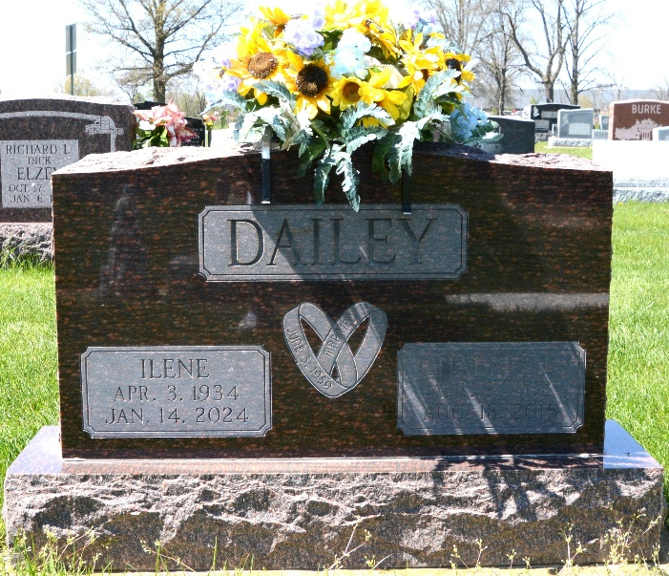
Photo by Deb Curry

Ilene M. Dailey, 89, of Berne, Indiana passed away Sunday afternoon, January 14, 2024, at her residence. She was born on April 3, 1934, in Decatur, Indiana to the late Jake Shaffer and the late Lula (Wolfe) Shaffer. She was united in marriage to Charles L. Dailey on June 5, 1959, at the First Presbyterian Church in Decatur, Indiana and he preceded her in death on August 18, 2015.
She was a telephone operator for over 40 years at GTE.
Ilene loved watching all sports and attending her grandchildren’s sporting events never missing an event. She enjoyed painting and drawing. In her spare time, she enjoyed Sudoku and crossword puzzles.
She is survived by her daughter, Melinda “Mo” (Art Eichhorn) Case of Decatur, Indiana; son, Charles A. Dailey of Berne, Indiana; son, Dwayne L. Dailey of Berne, Indiana; sister, Bonnie Griggs of Owensboro, Kentucky; sister, Babara Shaffer of Decatur, Indiana; sister, Nancy Shaffer of Decatur, Indiana; brother, Harlan “Bus” (Patsy) Shaffer of Monmouth, Indiana; brother, David Shaffer of Decatur, Indiana; brother, Larry Shaffer of Decatur, Indiana; brother, Terry (Carla) Shaffer of Convoy, Ohio; five grandchildren, Troy Walker, Jamie Stout, Travis (Ashley) Case, Michael Case and Briona Case; four great-grandchildren, Kobey Eaton, Kaiden Stout, Colt Case, and Cora Case.
Ilene was preceded in death by a son, Ron E. “Rounder” Dailey; grandson, T.J. Elzey; three brothers, Don “Bud” Shaffer, Charles “Short” Shaffer, and Jerry “Jug” Shaffer and three sisters, Patsy Blew, Connie Hess, and Debra Shaffer.
In honoring Ilene’s wishes, no services will be held.

Zwick & Jahn Funeral Home, Adams County, Indiana
January 16, 2024

