Anna A. (Oakley) Dague
December 29, 1898 – February 5, 1966

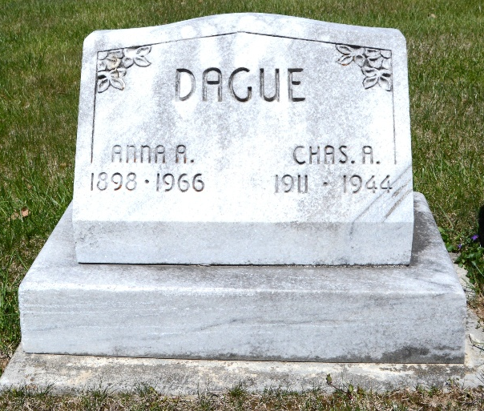
Photo by Deb Curry

Mrs. Anna Dague dies early today

Mrs. Anna A. Dague, 67, of 827 North Third street, died at 12:50 a.m. today at St. Joseph’s hospital in Logansport where she had been visiting a son. She was born in Ohio City, O., Dec. 27, 1890, a daughter of Jim and Sarah Rainey-Oakley.
Mrs. Dague was a member of St. Mary’s Catholic church, and the VFW, DAV, Eagles and American Legion auxiliaries.
Surviving are four sons, John Smith of Fort Wayne, Herman Smith of Portland, David Smith of Decatur, and Robert Dague of Logansport; and 12 grandchildren. One daughter is deceased.
Funeral rites will be held at 9:30 a.m. Monday at St. Mary’s Catholic church, with Rt. Rev. Msgr. Simeon Schmitt officiating. Burial will be in the Decatur Cemetery. Friends may call at the Winteregg-Linn funeral home after 12 noon Sunday until time of the services.

Adams County (IN) Public Library
Obit Book D, image 26
Dated February 5, 1966
**
Indiana, Death Certificates, 1899-2011
Name: Anna A Dague [Anna A Oakley]
Gender: Female; Race: Caucasian (White)
Age: 67; Marital status: Widowed
Birth Date: 29 Dec 1898; Birth Place: Ohio
Death Date: 5 Feb 1966; Death Place: Logansport, Cass, Indiana , USA
Father: Jim Oakley; Mother: Sarah Rainey
Informant: Robert Dague; son; Logansport, Ind.
Burial: Feb. 7, 1966; Decatur Cem., Decatur, Ind.

