Joseph E. Butler
July 6, 1937 – September 7, 2021

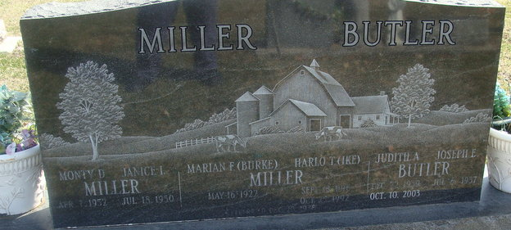
Photo by Alicia Kneuss

Joseph E. Butler, 84, of Decatur, Indiana passed away Tuesday morning, September 7, 2021, at his residence. Joe was born on July 6, 1937 in Decatur, Indiana to Hubert E. and Luella A. (Kelley) Butler. On May 3, 1958, Joe married Judith A. Miller and she preceded him in death on October 10, 2003.
Joe was a former member of Indiana Auctioneering Association.
He was a self-employed auctioneer and was the owner of J & J Butler in Willshire, Ohio. He had previously worked at Central Soya Farm Supply in Decatur and Phelps Dodge in Fort Wayne.
Joe loved farming and spending time taking care of his animals. He also enjoyed his racing horse, Tare Weight. In his younger years, Joe enjoyed swimming. He had a special place in his heart for his great-granddaughter, Luella.
He is survived by daughter, Christine Butler of Decatur, Indiana; son, Jeffery (Carolyn) Butler of Decatur, Indiana; daughter, Stacey Butler of Decatur, Indiana; two brothers, Paul (Beverly) Butler and Jim (Beverly) Butler both of Decatur, Indiana; nine grandchildren, Tyler (Joy) , Joey, William, Patrick, Brittaney (Tre) , Austin, Tiffany, Justin, Lindsey; granddaughter-in-law, Amber Butler; and great-grand-daughter, Luella Butler. He is also survived by his caregiver, Sarah Tumbleson, of Decatur, Indiana.
Joe was preceded in death by a daughter, Amy Lou Butler; grandson, Rhett Butler; sister, Judy Murray; and brothers, Tom and Jack Butler.
A funeral service will be held at 10:00 a.m. Monday, September 13, 2021, at Zwick & Jahn Funeral Home in Decatur. Burial will follow at Decatur Cemetery. Family and friends will be received from 12 noon to 6 p.m. Sunday, September 12, 2021, at the Zwick & Jahn Funeral Home in Decatur
Preferred memorials are to National Federation for the Blind.

Zwick & Jahn Funeral Home, Adams County, Indiana
September 7, 2021

