Debra Kaye (Jamison) Bultemeier
February 11, 1955 — March 28, 2026

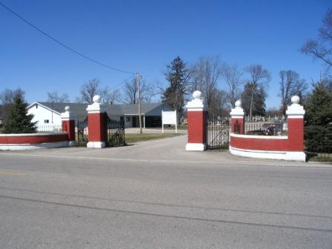
Photo by Barbara Baker Anderson

Debra Kaye Bultemeier, 71, of Decatur, Indiana, passed away on Saturday, March 28, 2026 at Adams Memorial Hospital in Decatur, Indiana. She was born on February 11, 1955 in Adams County, Indiana to the late Francis and Vera (Krick) Jamison. Deb was united in marriage to Brian Bultemeier on November 23, 1999 in Las Vegas, Nevada.
Deb was a waitress at the West End restaurant in Decatur, Indiana, where she enjoyed the relationships she established with many of her customers. After receiving her Marketing Degree from Indiana University, she worked as a purchasing manager at All American Homes in Decatur.
Her greatest love and joy was spending time with her children and grandchildren. Sports of many kinds were a part of her life. She especially valued the time spent watching her grandchildren. She never missed a sporting event where her grandchildren were participating. When she was younger, she was very involved in softball with her sisters and her friends. This transitioned into coaching youth softball teams which often included her providing the transportation and “being the bus” for several sports. Deb was an accomplished seamstress, and loved to sew for family and friends. She continued her skills as a seamstress by opening The Wild Radish Boutique, where her customers benefited from her creativity. She enjoyed planting flowers, especially tulips.
Survivors include her husband, Brian Bultemeier of Decatur, Indiana; daughter, Brande (Chad) Ringger of Bluffton, Indiana; son, Chris Morence of Bluffton, Indiana; sister, Darline (Carl) Nahrwold of Leo, Indiana; grandchildren, Emerson (Max) Rowley, Ava (Spencer) Pirtle, Jack (Alisa) Ringger, John (Madison) Ringger, and Cayden (Lydia) Shaffer; and great-grandchild, Stetson Shaffer.
She was preceded in death by her sister, Sherlie Walters and her brother, Robert Jamison.
A funeral service will be held at 10:30 a.m. on Thursday, April 2, 2026 at Zwick and Jahn Funeral Home, Decatur, Indiana, with Chad Ringger and Jack Ringger officiating. Burial will follow at Decatur Cemetery. Family and friends will be received from 2 to 4 and 5 to 7 p.m. on Wednesday, April 1, 2026 at Zwick & Jahn Funeral Home, Decatur, Indiana, and one hour prior to the service on Thursday.
Preferred memorials can be given to Wells Community Boys and Girls Club.

Zwick & Jahn Funeral Homes, Adams County, Indiana
April 5, 2026

