Paul G. “Pete” Brown
April 10, 1935 – May 21, 2011

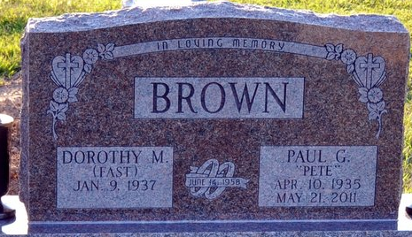
Photo by Deb Curry

Paul "Pete" Brown, 76 years old of Ohio City, Ohio, passed away on Saturday, May 21, 2011 at his residence. He was born on Wednesday, April 10, 1935 in Adams County, Indiana the son of the late Herman Brown and the late Eva Clive (Kresicher) Brown. He married Dorothy Fast on June 14, 1958 in Union Chapel Church in rural Decatur, Indiana.
Pete attended Monmouth High School and served in the United States Army Reserves for eight years. He attended Calvary Church in Van Wert, Ohio. He retired in 1986 from International Harvester with thirty-five years of service and was also a longtime farmer in Harrison Township, Ohio.
Surviving are his wife, Dorothy Brown of Ohio City, Ohio; daughter, Leesa Brown of Columbus, Ohio; daughter, Tonya Brown-Stobbe of Morgantown, West Virginia; son, Bradley (Alesia Yakos-Brown) Brown of Convoy, Ohio; brother, Dale (Vivian) Brown of Poe, Indiana; brother, Dan Brown of Decatur, Indiana; sister, Ilo (Floyd) Meyer of Ohio City, Ohio; sister, Iris (Darrell) Hendricks of Huber Heights, Ohio; sister, Connie (John) Martin of Kokomo, Indiana; and four grandchildren, Brooke Brown-Stobbe; Jordan Brown-Stobbe; Alex Brown and Carter Brown.
Preceding Paul in death were six brothers; H. Don, Max, Marvin, Ronald, Raymond & Larady Brown.
Funeral services will be held at 11:00 a.m. Wednesday, May 25, 2011 in the Zwick & Jahn Funeral Home with Rev. Ron Johnson officiating. Interment will follow in the Decatur Cemetery. Friends will be received from 2-4 and 5-8 p.m., Tuesday, May 24 in the Zwick & Jahn Funeral Home, Decatur.
Preferred memorials are to Community Health Professionals Inpatient Hospice Center in Van Wert, Ohio.

Zwick & Jahn Funeral Home, Adams County, Indiana

