Mariah Elizabeth (Sager) Brown
September 24, 1820 – June 3, 1899

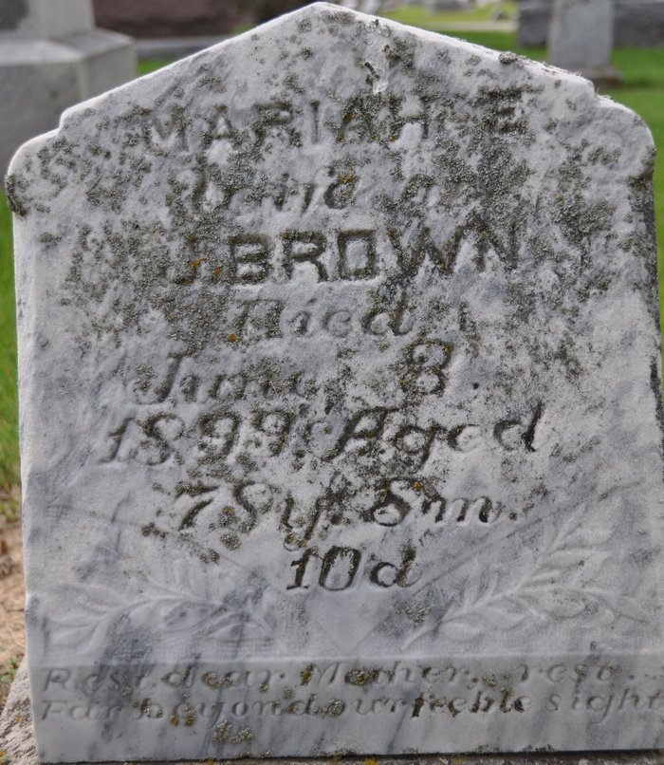
Photo by Deb Curry

The death of Mrs. John Brown occurred at her home east of the city Saturday afternoon, of paralysis, having been ill for several weeks.
Funeral services were held from the Presbyterian Church in this city, Monday morning, Rev. Duckett officiating.

Decatur Democrat, Adams County, Indiana
(a weekly newspaper)
Thursday, June 8, 1899

**
Aged Lady Dead

Mrs. John Brown died at 5 o’clock Saturday evening, and her funeral was held from the Presbyterian Church this morning, conducted by Rev. H C. Duckett.
Mariah E. Sager was born in Union County, Ohio, September 24, 1820. She died at her home in Root Township, Adams County, Indiana, June 3, 1899, aged 73 years, 8 months and 19 days.
She was united in marriage to John Brown June 27, 1839. To this union was born sixteen children, nine sons and seven daughters. One son and two daughters preceded her to the spirit land. She leaves, therefore, an aged companion, eight sons and five daughters to mourn their loss.
She was confirmed in the Lutheran Church at the age of fourteen. She moved with her companion to Wayne County, Ohio, in 1843. In 1846 she united with the Presbyterian church. In 1852 she moved with her family to Adams County, Indiana, where she renewed her membership in the church of her choice at Decatur and continued faithful until death called her from labor to her reward. Her companion with whom she lived almost three score years, and the children all unite in saying she was a loving and devoted wife and mother. Goodbye mother, until we meet again.

Decatur Weekly Journal, Adams County, Indiana
Friday, June 9, 1899

