Wanda M. (Bailey) Boyd
May 27, 1923 – September 13, 2021

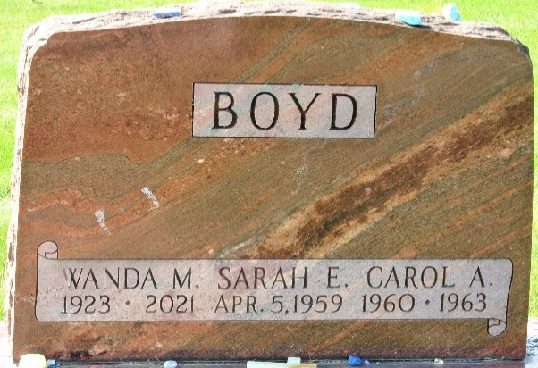
Photo by PLS

Wanda M. Boyd, 98, of Decatur, Indiana passed away early Monday, September 13, 2021, at Adams Heritage in Monroeville, Indiana. She was born May 27, 1923 in Pleasant Mills, Indiana to John L. and S. Edith (Battenberg) Bailey.
Wanda was a member of the First United Methodist Church in Decatur and was previously active in the United Methodist Women and The Wesleyans and had served as the Sunday school secretary for over 25 years. She was also a volunteer at The Hope Chest in Decatur and at Adams County Memorial Hospital.
In her younger years, Wanda had been employed at General Electric in Fort Wayne and then worked at Stockman Farm Service in Decatur.
Wanda was an avid walker and continued to walk into her 90’s. She enjoyed watching birds and reading.
She is survived by three daughters, Linda (Leo) Ley of Naperville, Illinois, Karen Darling and Diane Kaehr both of Decatur, Indiana; son, Mike (Terri) Boyd of Decatur, Indiana; eight grandchildren; and ten great-grandchildren.
She was preceded in death by her parents; two children, Carol A. Boyd and Sarah E. Boyd; a sister, Wilma Everett and two brothers, Lyle and Herald Bailey.
A funeral service will be held at 2 p.m. Monday, September 20, 2021, at First United Methodist Church in Decatur with Pastor Harold Klinker officiating. Interment will follow at Decatur Cemetery.
Family and friends will be received from 12 noon to 2 p.m. Monday at the church.
Preferred memorials are to First United Methodist Church in Decatur.

Zwick & Jahn Funeral Home, Adams County, Indiana
September 14, 2021

