Donald R. Bleeke
August 12, 1933 – October 21, 2020

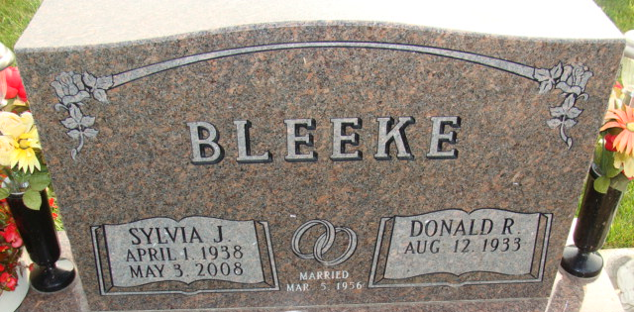
Photo by Alicia Kneuss
Donald R. Bleeke, 87, of Decatur, passed away on Wednesday, October 21, 2020, at Adams Heritage in Monroeville, IN. He was born in Decatur, on August 12, 1933, the son of Grover and Florence (Draper) Bleeke. On March 5, 1956, he married Sylvia Mazelin and after 52 years, she preceded him in death on May 3, 2008.
He attended Zion Lutheran Church in Decatur and worked at Decatur Casting. He enjoyed woodworking and selling crafts at crafts shows Donald enjoyed gardening and followed I.U. basketball. He was also an owner and operator of Jiffy Wash car wash and enjoyed many years at Lake James and time spent vacationing in Florida.
Donald served his country in the U.S. Army and was a proud great grandpa of four with another great granddaughter on the way.
He is survived by a son, Greg (Heather) Bleeke of Fort Wayne; a daughter, Linda (David) Lothamer of Fort Wayne; 5 grandchildren, Doug (Christina) Lothamer, Brad (Tori) Lothamer, Kristen (Amir) Faghih, Sarah and Sam Bleeke; a sister, Kathleen Jones of Decatur.
Donald was preceded in death by 2 sisters, Phyllis Lasch and Martha Sprunger; a brother, Ronald Bleeke.
Due to Covid 19 health concerns, there will be a Private Graveside Service held at Decatur Cemetery.
Memorials may be made to Zion Lutheran Church or Visiting Nurse Hospice.

Haggard & Sefton Funeral Home, Adams County, Indiana
October 22, 2020

