Joseph L. Betz
December 25, 1943 – November 30, 2025

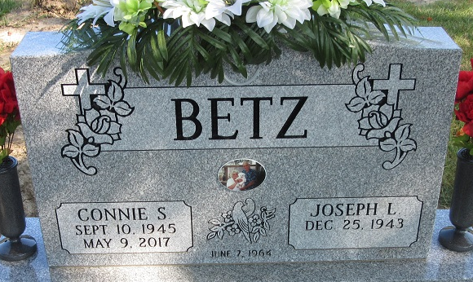
Photo by PLS

Joseph Lee Betz, 81, of Decatur, IN, passed away on Sunday, November 30, 2025 at Parkview Regional Medical Center in Ft. Wayne. Joseph was born in Bluffton, IN on December 25, 1943 to the late George Edward and Annabelle (Leach) Betz. On June 7, 1964, Joseph married Connie Webb.
Joseph attended Common Ground Church. He retired from Dana Corp. as a gear cutter.
He is survived by 2 daughters, Jessica (Duane) Yoder and Billie Jo (Terry) Lister both of Decatur, IN; 2 brothers, 4 sisters and 4 grandchildren.
Joseph was preceded in death by his wife Connie Betz; 3 brothers, 3 sisters.
Funeral Services will be held on Thursday, December 4, 2025 at 1:00 p.m. at Haggard-Hirschy & Zelt Funeral Home with visitation prior from 10:00 a.m. – 1:00 p.m., with Pastor Dan York officiating. Burial will follow in Decatur Cemetery.
Preferred memorials may be made to P.A.W.S. of Adams County.

Haggard-Sefton & Hirschy Funeral Home, Adams County, Indiana
November 30, 2025

