Martin Beery
November 29, 1846 – November 26, 1923

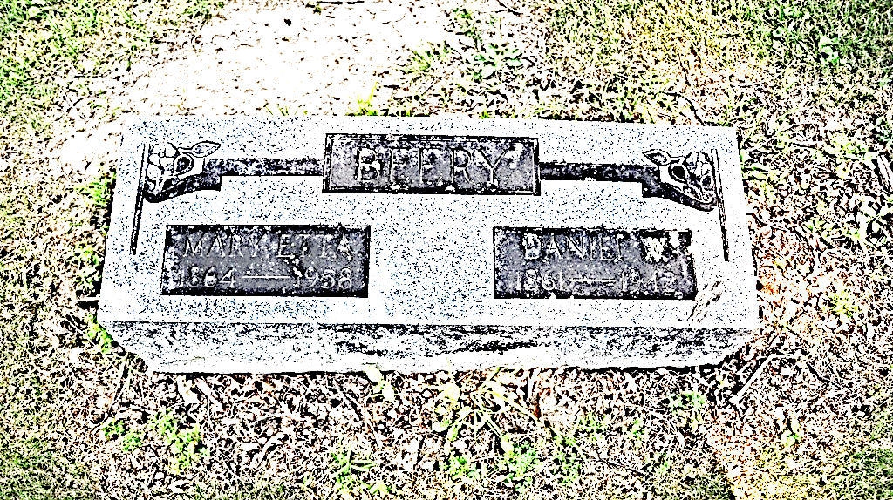
Photo by Alicia Kneuss

BEERY FUNERAL ON WEDNESDAY
Funeral Services for Martin Beery at Methodist Church 1:30 P.M.
Funeral services for Martin Beery, well-known citizen of Decatur, who died at the Adams County Memorial Hospital yesterday afternoon, will be held from the First Methodist Episcopal Church at 1:30 o’clock Wednesday afternoon. Burial will be made in the Maplewood Cemetery.
Martin Beery, son of Eli and Hester Beery was born in Adams County, Indiana, November 29, 1846, being 77 years, and 20 days old at the time of his death. Mr. Beery grew to manhood in Kirkland Township and did his part in transforming the native wilderness into a splendid farming community.
On October 17, 1872, Mr. Beery was united in marriage to Martha E. Shady of Wells County. She was a daughter of Joseph and Elizabeth Shady. Mr. and Mrs. Beery began married life on a farm in Kirkland Township where they resided until 1883, when they moved to St. Mary’s Township. Mr. Beery continued his farm work until he suffered a stroke pf paralysis in the autumn of 1898. Since that time, he has resided in this city, afflicted more or less with rheumatism and paralytic effects. For the past two or three years he had suffered much pain.
On the 18th of this month, Mr. Beery was taken to the Adams County Memorial Hospital in the hopes that an operation might bring relief. It was of no avail and he rapidly declined until death came. A post mortem held this morning showed that death was due to a cancerous condition of the bladder.
At the age of 30 years, Mr. Beery united with the Church of the Brethren in Christ at Antioch, four miles west of this city. At the time of his death, he was a member of the First Methodist Church of Decatur, having transferred his membership. Mr. Beery was a real Christian and often said that the greatest satisfaction of his life was to know where he was going when he left this life.
Besides the beloved wife, Mr. Beery leaves the following children to mourn his departure: Mrs. C.H. Colter, Wilson F. and Edwin, all of this city; Freeman Beery, of Connersville; and Sherman Beery, of Ypsilanti, Mich. One daughter, Matilda, preceded him in death, having died in 1893. There are nine grandchildren and one great-grandchild, four brothers, Ruben of Peterson, Christ, John and Daniel, all of this city.
Decatur Daily Democrat, Adams County, Indiana
Tuesday, November 27, 1923

