Raymond Becher, Jr.
April 18, 1935 – November 26, 2020

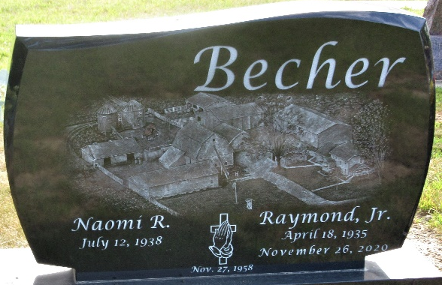
Photo by PLS

Raymond Becher Jr., 85, of Decatur, Indiana, passed away Thursday, November 26, 2020, at Adams Memorial Hospital after an extended illness and of natural causes.
He was born on April 18, 1935, in Adams County, Indiana to the late Raymond O. Becher and the late Clara (Fogle) Becher. Ray was united in marriage to Naomi R. Kirchhofer on November 27, 1958 at the Zion United Church of Christ in Decatur and she survives.
Ray was a member of the Zion Lutheran Church in Decatur. He also was active in the Dairy Shrine Club (Life Member), Indiana Holstein Association (Life Member) along with being the District IV Holstein Club past President, Secretary, and Treasurer along with serving on the Adams County Dairy Herd Improvement Association Board. Volunteering his time to help youth interested in farming, Ray was active in the Adams County 4-H program where he served on the Calf Club and the 4-H Extension Board.
He was a 1954 graduate of Adams Central High School. Ray was a lifelong Grain and Dairy Farmer in Adams County, operating Ray-Na Holstein Farm. Ray had a passion and zeal for dairy farming and was nationally known for breeding Holstein Cattle. His knowledge of dairy farming resulted in his service on the Senator’s Farm Advisory Committee. In 1978, Ray bred and exhibited the All American & Reserve All American three year Holstein cows. He was the first Holstein breeder to be inducted into the Purdue Hall of Fame. He was the recipient of the Master Breeder Award in Indiana. He also won the Indiana Master Farmer Award, Dairy Family of the Year, and Progressive Breeder’s Award which he won 15 times (highest in nation for a homebred herd).
Survivors include his wife of 62 years, Naomi Becher of Decatur, Indiana; four daughters, Amy Jo (Gregory) Fumarolo of Fort Wayne, Indiana, Audrey A. (Cameron) Erekson of Bristol, Indiana, Angela S. (David) Brite of Decatur, Indiana, and April L. (Jerome) Isch of Decatur, Indiana; nine grandchildren, Shawn Hany, Erin (Derrick) Kovell, Ryan Hany, Spencer (Brittany) Erekson, Reid (Anisha) Erekson, Emily and Noah Brite, Anna and Aidan Isch; two great-grandchildren, Reagan & Simon Erekson, and one on the way; and step-grandchildren.
Ray was preceded in death by three sisters and their spouses, Fonteen (Lester) Haines, Catherine (Paul) Longsworth and Marjorie (Robert) Lobsiger; and one brother, Norman (Arlene) Becher.
Private funeral services for Ray will be held at Zion Lutheran Church in Decatur with Pastor James Voorman officiating, for the immediate family with burial following at Decatur Cemetery.
In lieu of flowers, Ray’s family would ask that donations and memorials be directed to the Zion Lutheran Church, or Adams County 4-H and can be sent to the Zwick & Jahn Funeral Home, Decatur office.

Zwick & Jahn Funeral Home, Adams County, Indiana
November 27, 2020

