Naomi R. (Kirchhofer) Becher
July 12, 1938 – May 28, 2023

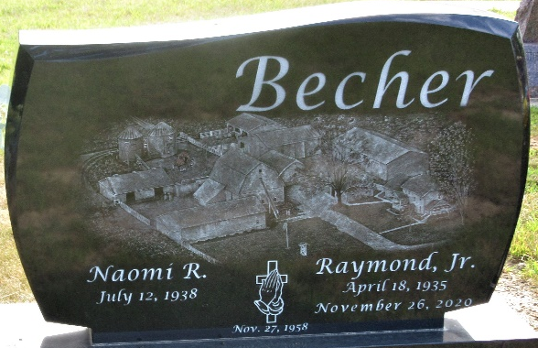
Photo by PLS

Naomi R. Becher, 84, of Decatur, Indiana passed away Sunday, May 28, 2023, at Adams Woodcrest in Decatur. She was born on July 12, 1938, in Adams County to the late Rufus Kirchhofer and the late Viola (Fox) Kirchhofer.
Naomi was united in marriage to Raymond Becher, Jr. on November 27, 1958, at United Church of Christ in Decatur, Indiana and he preceded her in death on November 26, 2020.
Naomi graduated from Monmouth High School class of 1956. She was a member of Zion Lutheran Church in Decatur where she served as the church Secretary and was on the Zion Lutheran Church Missionary Society. Naomi was a 4-H Leader for over 20 years, and served on the 4-H Extension Board, and 4-H Council. She was an Executive Board member of the Decatur Christian Women's Club.
She faithfully served alongside her husband Raymond on their Grain and Dairy Farm in Adams County, operating Ray-Na Holstein Farm where they were nationally known for breeding Holstein Cattle.
Naomi enjoyed spending time with her children, grandchildren and great-grandchildren. In her younger years she enjoyed reading, crocheting, tending her flower beds, and baking.
She was preceded in death by sister, Bernadine Ehrman.
A funeral service will be held at 10:30 a.m. Friday, June 2, 2023 at Zion Lutheran Church in Decatur with Pastor Zachary Oedewaldt officiating. Burial will follow in the Decatur Cemetery. Family and friends will be received from 4-8 p.m. Thursday, June 1, 2023 at the Zwick & Jahn Funeral Home in Decatur and one hour prior to the service on Friday at the church.

Zwick & Jahn Funeral Home, Adams County, Indiana
May 29, 2023

