Margaret A. (Cherry) Badders
December 31, 1881 – March 21, 1981

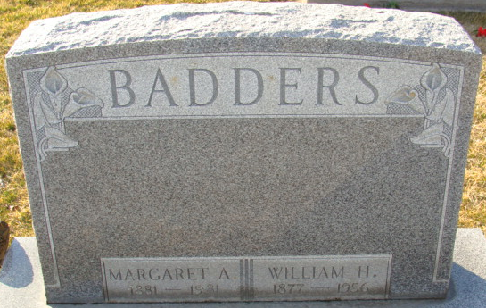
Photo by Alicia Kneuss

Margaret Badders
in the U.S., Social Security Death Index, 1935-2014
Name: Margaret Badders
SSN: xxx
Last Residence:
80206 Denver, Denver, Colorado, USA
Born: 31 Dec 1881
Last Benefit: 80231, Denver, Denver, Colorado, United States of America
Died: Mar 1981
State (Year) SSN issued: Indiana (1954)
**
Michigan, Marriage Records, 1867-1952

Name: Margaret Ann Cary
[Margaret Ann Cherry]
Gender: Female
Race: White
Age: 41
Birth Year:abt 1882
Birth Place: Indiana
Marriage Date: 3 Oct 1923
Marriage Place: Hillsdale, Hillsdale, Michigan, USA
Residence Place: Ft Wayne, Indiana
Father: Wm H Cherry
Mother: Ella Hewes
Spouse: William Henry Badders
Record Number: 1350

