Eva (Kress) Auth
April 25, 1840 – April 7, 1923

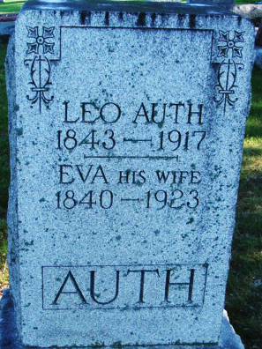
Photo by Alicia Kneuss

MRS. EVA AUTH DIED SATURDAY
One of Oldest Residents of City Expired Following Brief Illness

Mrs. Eva Auth, age 83 years, one of the oldest residents of the city, died at her home on South Eleventh Street at 10:40 o’clock Saturday night, following an illness of influenza for the past three weeks.
Mrs. Auth was born in Germany and came to this country forty-nine years ago. She and her husband located in this city where she has resided continuously since that date.
Two sons and one daughter survive. They are Paul, of this city; Philly, of Denver, Colorado, and Mrs. James DeWitt, of Bluffton. There are six grandchildren and one great-grandchild, also. The husband and one daughter preceded her in death.
Funeral services will be held from the Zion Lutheran Church at 2:30 o’clock Tuesday afternoon. Short services will be held from the home at 2 o’clock. Burial will be made in Maplewood Cemetery.
Decatur Daily Democrat, Adams County, Indiana
Monday, April 9, 1923

**
Indiana, Death Certificates, 1899-2011

Name: Eva Auth
[Eva Crush]
Gender: Female; Race: White
Age: 89
Marital status: Widowed
Birth Date: 25 Apr 1840; Birth Place: Germany
Death Date: 7 Apr 1923; Death Place: Decatur, Adams, Indiana, USA
Father: John Crush b. Germany
Mother: Martha Crush b. Germany
Informant: Paul Auth
Burial: April 10, 1923; Decatur Cemetery

