Oliver P. Auten
1843 – October 25, 1901

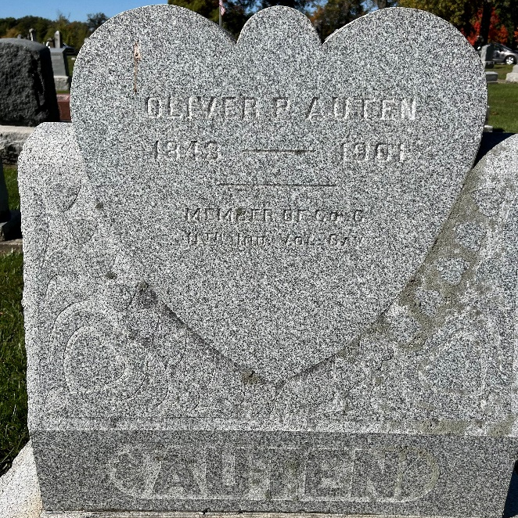
Photo by Alicia Kneuss

Oliver Auten died suddenly last Friday morning about eleven o'clock of heart trouble at the home of Wm. Gilbert in the southwest part of town, where he had boarded for some time. He was down street during the morning and seemed in his usual health. About seven o'clock he swept out for H. A. Fristoe and to him complained of a peculiar pain over the heart says, "I never felt just that way before," and seemed considerably worried. He was also into Coffee & Bakers restaurant, Blackburn & Christens drug store and other business houses but showed no signs of illness. About ten o'clock he returned to his boarding house and an hour later was found dead in the back yard.
The deceased was born in Carroll County, Ohio in 1844 and was fifty-seven years of age at the time of death. He came to this county with his parents when he was about five years old and located on a farm near Monmouth. There he resided until 1861, when at the call of his country for troops, he joined the 11th Indiana cavalry. He served during the war and was a brave and patriotic soldier. After receiving his discharge he returned to this country and has since lived here going away during the summer often but returning after a few months. He was well known here and in the north part of the county.
The funeral services were held Sunday morning from the home of Samuel Pillars, north of town, Rev. Mider, of Hoagland, officiating. The G. A. R. attended in a body and conducted their army services for such an occasion.

Decatur Democrat, Adams County, Indiana
Thursday, October 31, 1901

**
Oliver P Auten from tree Genealogical Studies of Rev. A. J. Fretz

Birth 1843 Carroll, Ohio, USA
Marriage 1 Feb 1864 Allen, Indiana, USA
Death 25 Oct 1901 Adams, Indiana, USA
Father Jacob Auten (1811-1888)
Mother Martha Foster (1802-1873)
Spouse Martha Mumma Lower (1841-1915)
182808 People 5 Records 5 Sources

