Betty Jean (Seip) Ashley
January 3, 1951 – September 16, 2024

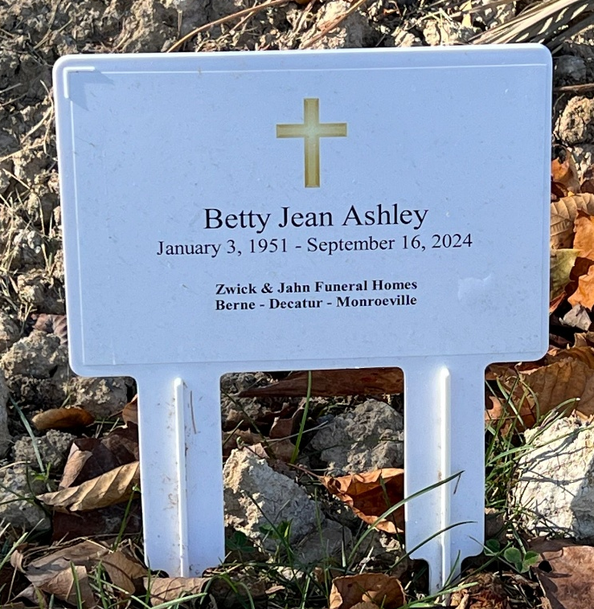
Photo by Deb Curry

Betty Jean Ashley, 73, of Decatur, Indiana passed away Monday morning, September 16, 2024, at Lutheran Hospital in Fort Wayne, Indiana. She was born on January 3, 1951, in Evansville, Indiana to the late Elmer W. Seip and the late Betty C. (Rhoades) Bailey. On October 29, 1966, Betty married Tommy N. Ashley in Tampa, Florida.
Betty attended the Decatur Church of God and was a member of the Women of the Moose in Decatur. She had worked for Tri Tech Systems, Inc. in Decatur and was previously employed at Fleetwood for 12 years, and worked in daycare for eight years. Betty enjoyed bowling for many years. Betty loved sewing and quilting. In her spare time, she enjoyed playing bingo.
She is survived by her husband, Tommy Ashley of Decatur, Indiana; son, Terry Neal (Theresa) Ashley of Decatur, Indiana; son, Kurtis Wade (Becky) Ashley of Decatur, Indiana; son, Brian Paul (Brandi) Ashley of Decatur, Indiana; daughter, Shanna (Sam) Burgin of Decatur, Indiana; step-mother, Patsy Ponds of Downers Grove, Florida; brother, William Elmer (Joyce) Seip of Decatur, Indiana; sister Esther (Jerry) Kline of Decatur, Indiana; twin brother, Jerry Lee (Pam) Seip of Owenton, Kentucky; twin brother, Harry John Seip of Indiana; brother, Dennis Dewayne (Tammy) Seip of Geneva, Indiana; 16 grandchildren, Nick (Megan) Weldy, Taya (Patrick) Gonzalez, Alyssa (Jordan) Rucks, Kyle Ashley, Lauren (Adam) Seymour, Ryan (Breana) Ashley, Adrienne (Ben) Fullenkamp, Brooke (Daniel) Swygart, Holly Ashley, Cleo Burgin, William Wemhoff, Samuel Burgin II, Jillian Wemhoff, Noah Burgin, Aidan Wemhoff, and Bella Ashley; and 13 great-grandchildren.
Betty was preceded in death by a son, Anthony Wayne Ashley in infancy, and a brother, Andrew E. Seip.
A funeral service will be held at 10:30 a.m. Friday, September 20, 2024, at the Zwick & Jahn Funeral Home in Decatur, Indiana with Pastor Eugene Hill officiating. Burial will follow at Decatur Cemetery. The family will receive friends from 2:00 to 5:00 and 6:00 to 8:00 p.m. Thursday, September 19, 2024, at the Zwick & Jahn Funeral Home and one hour prior to the service on Friday.
Preferred memorials can be given to Adams Central Band or Mooseheart in Decatur.

Zwick & Jahn Funeral Homes, Adams County, Indiana
September 17, 2024

