Izora J. (Mann) Archbold
February 14, 1871 – September 22, 1922

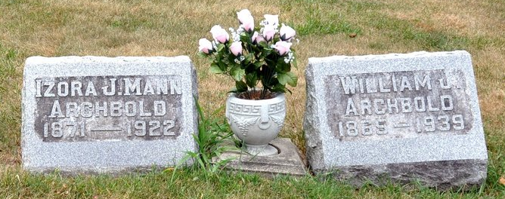
Photo by Barbara Baker Anderson

MRS. ARCHBOLD EXPIRED TODAY
Wife of William Archbold Died at Home on North Tenth Street

Mrs. Izora Jane Archbold, age 51 years, died at her home at 318 North Tenth Street, at 11 o'clock this morning, following an illness with Bright's Disease and a complication, dating from last July. She was the wife of William Archbold, who survives.
Mrs. Archbold was born in Root Township, Adams County, February 14, 1871. She was married to William Archbold on September 25, 1890, and since that date has resided in Decatur.
She has been a member of the Methodist Church here since she came to this city.
Five children survive: They are Lawrence E. Archbold, of Decatur; Marion J. Archbold of Garrett; and Earl, Esther, and Catherine, at home. Mrs. Louisa Mann, of Root Township, is the mother of Mrs. Archbold. The following brothers and sisters also survive: Harlow and John Mann of Root Township; Robert Mann, of Pleasant Mills; Frank Mann, of Rochester; Mrs. Shelby Vance, of near Willshire, Ohio; Mrs. Nettie Singleton, of Root Township; Mrs. Ethel Grandstaff, of Preble; and Mrs. Vera Sprague, of this city.
Funeral services will be held from the Methodist Church at 2 o'clock Sunday afternoon, the Rev. U. S. A. Bridge, pastor, officiating. Burial will be held in the Decatur Cemetery.

Decatur Daily Democrat, Adams County, Indiana
Friday, September 22, 1922

