Margie J. (Smitley) Andrews
September 7, 1934 – May 27, 2024

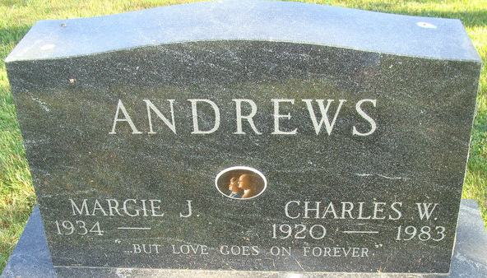
Photo by Alicia Kneuss

Margie J. Andrews, 89, of Berne, Indiana, and a former longtime resident of Decatur, Indiana before moving to Lake George passed away on Monday, May 27, 2024, at Swiss Village in Berne, Indiana.
She was born on September 7, 1934, in Jefferson Twp in Adams County to the late Ralph C. Smitley and the late Atla M. (Yaney) Smitley. Margie was united in marriage to Charles W. “Andy” Andrews on November 17, 1967, and he preceded her in death on April 9, 1983.
She graduated from Geneva High School Class of 1952. She attended Presbyterian Chapel of the Lakes at Lake George and formerly attended the Decatur Church of God and also the Decatur Missionary Church. Margie was also a member of the G.E. Retired Ladies and the G.E. Quarter Century Club.
Margie was employed at General Electric in Decatur for 36 years before retiring in September of 1989. She also owned and operated Andrews’ Ceramics shop in Decatur for many years.
Survivors include several nieces and nephews.
Margie was preceded in death by four sisters, Verlyn Cook, Lela Kelly, Christene Hofstetter, and Melba Overman; five brothers, Chester, Grant, Ralph Jr., Darrol Smitley, and J.V. Smitley.
A funeral service will be held at 1:00 p.m. Friday, May 31, 2024, at the Zwick & Jahn Funeral Home, Decatur with Pastor Mike Wertenberger officiating. Burial will follow at the Decatur Cemetery.
Family and friends will be received from 11:00 a.m. until the 1:00 p.m. service on Friday, May 31, 2024, at the Zwick & Jahn Funeral Home in Decatur.
Preferred memorials can be given to Presbyterian Chapel of the Lakes, Gideon’s International, or Lakewood Park Christian School.

Zwick & Jahn Funeral Home, Adams County, Indiana
May 28, 2024

