Rev. Patricia A. (Byrd) Agler
December 8, 1936 – September 15, 2005

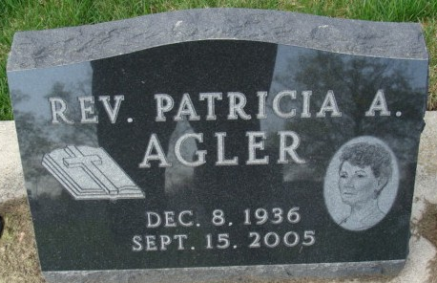
Photo by Alicia Kneuss

REV. PATRICIA A. AGLER

Rev. Patricia A. Agler, 68, of Decatur, died Thursday, Sept. 15, 2005, 10:15 p.m., at Lutheran Hospital. She was a former member of Calvary Temple, Fort Wayne and Sunday school teacher.
Surviving are her husband, Gayle D. Agler; son, Mike Blume of Decatur; daughters, Sandra Blume and Mrs. Ken (Angie) Miller, both of Fort Wayne; mother, Leona G. Clevenger of Decatur; sisters, Mrs. Leland (Phyllis) Bienz of Fort Wayne and Mrs. Steven (Judy) Haines of Ohio City, Ohio; and three grandchildren including Samantha Blume at home. She was preceded in death by one daughter, Pam Blume; and stepfather, Doyle R. Clevenger.
Service is 2:30 p.m. Monday at Zwick & Jahn Funeral Home, Decatur. Visitation is from 11 a.m. to 2 p.m. Monday and from 4 to 7 p.m. Sunday at the funeral home.

News-Sentinel, Allen County, Indiana
September 17, 2005

**
Indiana, U.S., Death Certificates, 1899-2017

Name Patricia A Agler
[Patricia A Byrd]
Gender Female
Race White
Marital Status Married
Age 68
Birth Date 8 Dec 1936
Birth Place Wren, Ohio
Death Date 15 Sep 2005
Death Place Fort Wayne, Allen, Indiana, USA
Father William Byrd
Mother Leona G Smith
Spouse Gayle D Agler, informant
Burial 9/19/2005 Decatur Cemetery

