Bobby Joe Wilker
July 11, 1948 – July 22, 2010

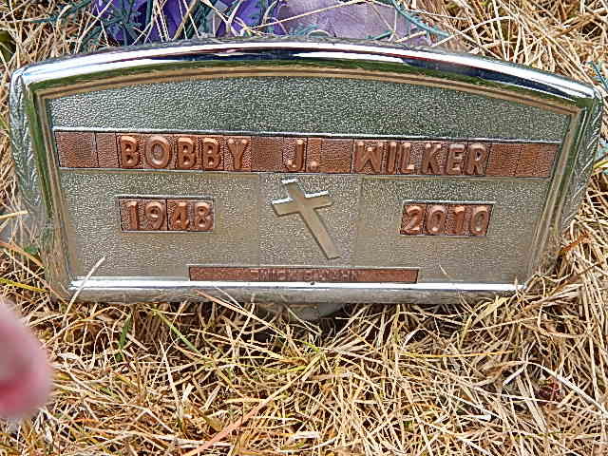
Photo by Alicia Kneuss

Bobby J. Wilker, 62 years old of Winchester, Indiana, passed away at 8:25 p.m. on Thursday, July 22, 2010 in the Reid Hospital located in Richmond, Indiana.
He was born on Sunday, July 11, 1948 in Greenville, Ohio the Son of the late Sam Wilker Sr. and Temple (Hayes) WilkerEmerick and she survives.
Prior to his disability, Bobby worked at Pizza King in Winchester, Indiana.
Surviving are his son, Bobby Joe Wilker of Dayton, Ohio; daughter, Tammy Sue Wilker of Dayton, Ohio; mother, Temple Emerick of Decatur, Indiana; brother, Sam Wilker of DeSota, Texas; sister, Dorene Baker of New Paris, Ohio; brother, Edward Emerick of Berne, Indiana; brother, Virgil Emerick of Decatur, Indiana; brother, John (Wendy) Emerick of Decatur, Indiana; brother, Mike (Tracy) Emerick of Lexington, Missouri.
Preceding Bobby in death was his step-father, Edward V. Emerick.
Funeral services will be held at 2:00 p.m. Tuesday, July 27, 2010 in the Zwick & Jahn Funeral Home with Rev. Ed Lovelace officiating. Interment will follow in the Beery Cemetery, Decatur, Indiana. Friends will be received one hour prior to the services.
Preferred memorials are to the family.

Zwick & Jahn Funeral Home online obit (accessed 7/28/2015)

