Daniel Weldy, Jr.
August 2, 1863 – April 15, 1892

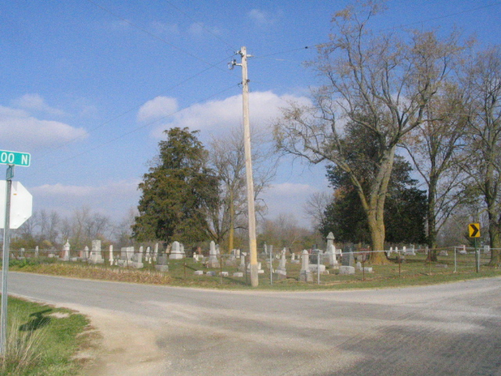
Photo by Barbara Baker Anderson

DIED - Daniel Weldy Jr., at the home of his brother, Seth Weldy, who resides at Peterson.
The deceased was twenty years of age and had been very low with consumption for some time. He was a young man highly esteemed by all who knew him and the community loses a ?? and respected citizen.
The funeral and interment took place at the Beery Church on last Sunday.

Decatur Democrat, Adams County, Indiana
Friday, April 22, 1892

