Julia A. (Werling) Straub
June 2, 1904 – July 6, 1995

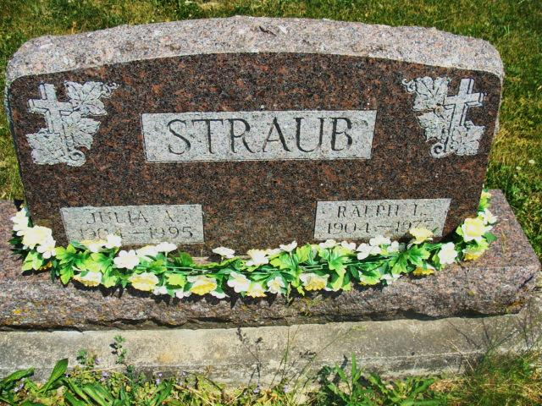
Photo by Alicia Kneuss

JULIA A. STRAUB, 91, of rural Decatur died yesterday in Chalet Village, Berne. The Adams County native was the widow of Ralph, who died in 1977. Surviving are a daughter, Virginia Klopfleisch of Decatur; son, Gale of Decatur; three grandchildren; and seven great-grandchildren. Services are 2 p.m. tomorrow in Haggard & Armes Funeral Home, Decatur, where calling is 2 to 5 and 7 to 9 p.m. today, and 10 a.m. to 2 p.m. tomorrow. Burial will be in Beery Cemetery. Preferred memorials are gifts to Mount Pleasant United Methodist Church, Decatur.

News-Sentinel, The (Fort Wayne, IN) - Friday, July 7, 1995

Contributed by Jane Edson

