William F. Stalter
November 30, 1863 – October 24, 1936

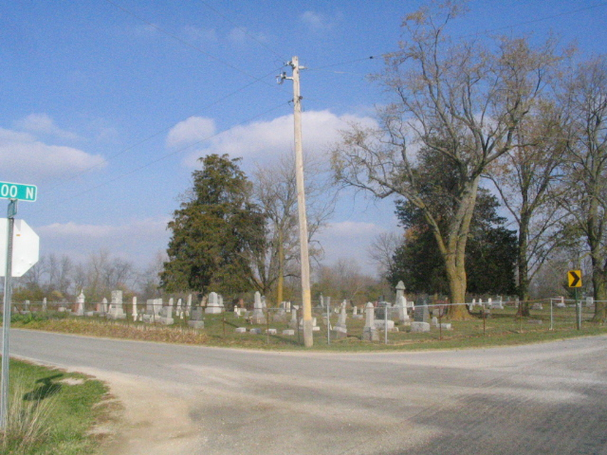
Photo by Barbara Baker Anderson

W. F. STALTER TAKEN BY DEATH - William Stalter Dies This Morning After Long Illness
William F. Stalter, 72, of route one Monroe, former resident of this city, died this morning at 5:20 o'clock of complications, following an illness of one year. Mr. Stalter was born November 30, 1863, in Allen County, Ohio, the son of Noah and Ella Lehman Stalter. He moved to Adams County 66 years ago. He lived in Decatur 19 years and moved to his farm early this spring.
He was married to Amanda Drum, of Wells County, January 1, 1886, who survives. Surviving are the following children: Norman S. Stalter, Fort Wayne; Clarence A. of Richmond, Delva A. of Fort Wayne and Allen F. of Dallas, Texas; and the following brothers and sisters: Rebecca Gearheart (sic) of Bluffton; George of Greenville, Ohio; Destiomey (sic) Stalter Wolf, Monroe; Enich (sic) of New Jersey; Doris Stalter Owens, Elkhart. Nine brothers and sisters are deceased. There are eight grandchildren.
Mr. Stalter was a retired farmer. He was a member of the United Brethren church of Decatur.
Funeral services will be held at the home three miles west of Monroe at 1:30 p.m. Tuesday and at 2 o'clock at the Antioch church. The Rev. J. W. Seager of Ohio and the Rev. E. S. Morford of Monroe will officiate at the services. Burial will be made in Antioch Church Cemetery.
The body will be returned from the S. E. Black Funeral Home Sunday morning and may be viewed from Sunday at 10 o'clock until time of the funeral.

Decatur Daily Democrat, Adams Co, Indiana
Saturday, October 24, 1936

