Noah Stalter
May 31, 1836 – January 16, 1916

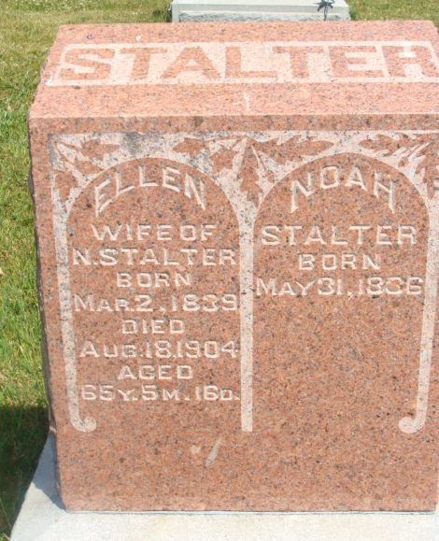
Photo by Alicia Kneuss

STALTER DEAD
Well Known Farmer and Minister of the Gospel Died Last Night
SOUTH OF MONROE Of Bright's Disease
Was Seventy-nine Years Old - Funeral Wednesday

Noah Stalter, a well-known farmer and minister of the gospel, long a resident of this county, died last night at 11:30 o'clock at this home, a mile and a half west and a half mile south of Monroe. Death was due to Bright's disease and he had been ailing for some time. Mr. Stalter was the son of Mr. and Mrs. Christian Stalter. He was born in Fairfield county, Ohio, May 30, 1836, but many years of his life were spent in this county. At death, he was seventy-nine years, seven months and sixteen days of age. His first wife died in August 1904, and the following children, born to them are living: Mrs. Ezra Reber southwest of the city; George, and Enoch Stalter and Dora McClaughlin, Elkhart; Destimona Wolfe and Will Stalter of southwest of this city. In March, 1906, he was married to Mrs. Eteline Valentine, the widow surviving. There are two sisters living, they being Mrs. Sarah Hilyard, Huntington, Mrs. Mary Allen, Uniondale. Four brothers and two sisters are deceased. They are Abraham, Christ, Isaac and George, Mrs. McClellan and Mrs. John McKean. The funeral will be held Wednesday. The procession will leave the house at nine o'clock for the Beery church, where services will be conducted at 10:30 o'clock. Interment in the Beery cemetery.

Decatur Daily Democrat, Adams County, Indiana, Monday, January 17, 1916 N.

*****
STALTER -- Information has been received in Lima telling of the death of Noah Stalter, 75 years of age, at his home in Decatur, IN. He was a brother to the late Christian N. Stalter of German Townshp, and was born on the home farm in German Township. He is an uncle of Frank A. Stalter of 1143 N. Main St, Ohio Electric Lineman and Benjamin McClellan of 110 West Grand Ave.

Lima Times Democrat, Allen County, Ohio; Jan 21, 1916

