Ellen (Lehman) Stalter
March 2, 1835 – August 18, 1904

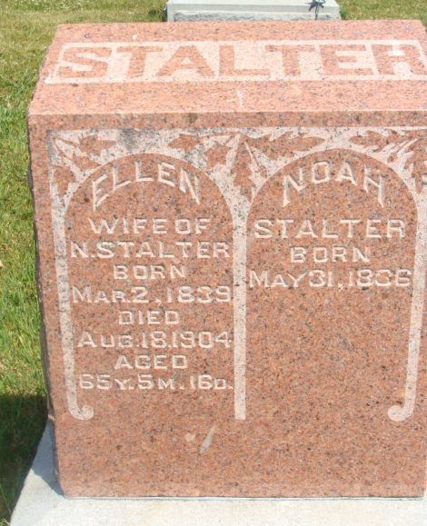
Photo by Alicia Kneuss

Sufferings End
Mrs. Noah Stalter Is Dead
Breathes Her last at Eight O'clock Last Night
Was Well Known Here

Last evening at eight o'clock at her home near Pleasant Mills, occurred the death of Mrs. Noah Stalter, after suffering for several months with dropsy. All during her early life, Mrs. Stalter had been a healthy and robust woman, and it was only at a recent date that it was finally determined that she was afflicted with dropsy, and her demise quickly followed - after this dread disease had once taken a firm hold on her system.
Mrs. Stalter was a member of the Christian Union Church, having joined this church when but a mere girl, and was always an ardent and devoted worker for Christianity, and all during her last illness was never heard to complain of her suffering, always placing her faith in her Lord, and saying, "Thy will be done."
The funeral services will be held tomorrow afternoon at 1:30 o'clock, sun time, at the Beery Church, the Rev. Payne officiating, and interment will be made at the Berry Cemetery.
She leaves a husband, four sons and four daughters to morn their loss, seven children having preceded her in death.

Decatur Daily Democrat, Adams Co., IN; Friday, August 19, 1904

