John G. Shoaf
September 30, 1802 – April 22, 1870

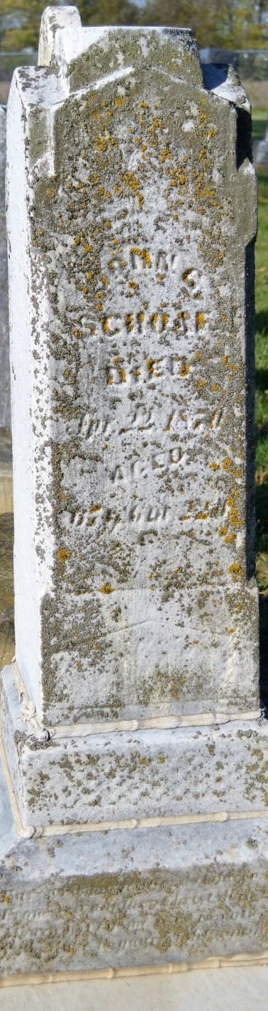
Photo by Colleen Sanders Broyles

No obit found at this time

