Leona (Stalter) Schrock
September 22, 1883 – September 27, 1941

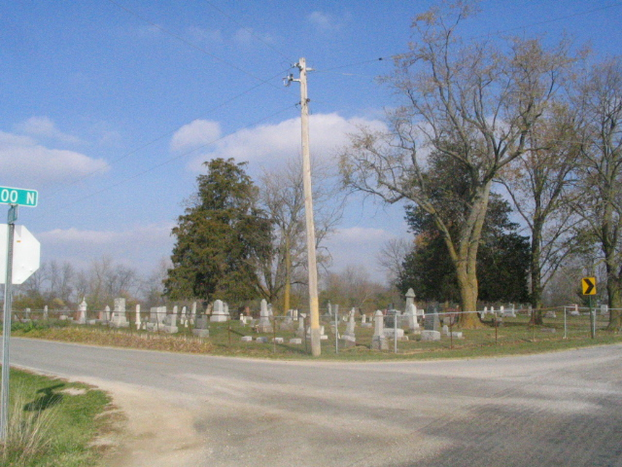
Photo by Barbara Baker Anderson

Indiana, Death Certificates, 1899-2011
Name: Mrs Leona Schaack [Mrs Leona Stalter]
Gender: Female; Race: White; Age: 58; Marital status: Married
Birth Date: 22 Sep 1883; Birth Place: Decatur, Ind
Death Date: 27 Sep 1941; Death Place: Rural, Whitley, Indiana
Father: John Stalter; Mother: Barbara Berry
Spouse: Melvin Schaack, informant
Burial: 9/30/1941, Antioch, Preble, Ind.

