Infant Russell
(unknown)

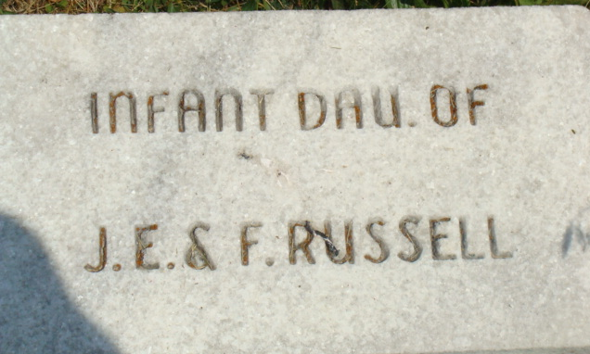
Photo by Alicia Kneuss

No obit found at this time

