Douglas D. Mills
October 21, 1886 – August 3, 1908

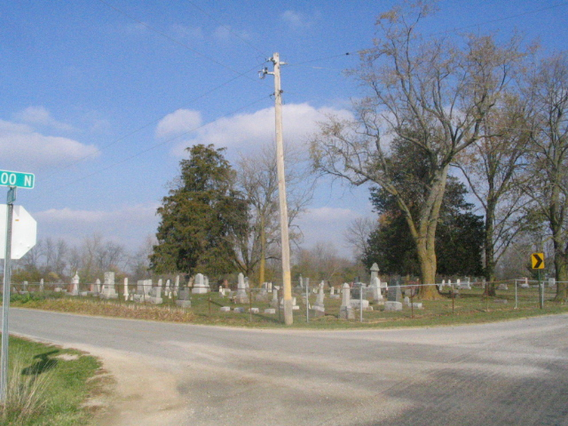
Photo by Barbara Baker Anderson

Mills

Douglas D. Mills, aged twenty-one years, and formerly a resident of this city, died Tuesday at Decatur of typhoid fever. For some time he was connected with the Homestead Art Company, of this city.
Surviving him are his grandfather, Samuel D. Beavers, of Decatur, and two sisters, Mrs. James Andrews of Monroe, Ind., and Mrs. John Crow, of Kansas.
The funeral will be held this morning in Decatur.

Journal-Gazette
August 6, 1908, Page 4

