Catherine J. (McConnehay) McWhirter
March 26, 1844 – February 3, 1914

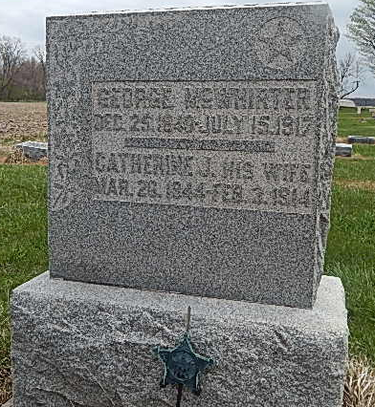
Photo by Alicia Kneuss

AT EARLY HOUR
Death Came Today To Mrs. George McWhirter of Near Peterson
WAS ILL LONG
Well Known Lady - Had Passed Age of Three Score and Ten
Catherine McConnehey McWhirter, wife of George McWhirter, prominent and highly respected resident of near Peterson, died this morning at 2 o'clock at the family home. She had been ill long of a complication of diseases, but death came very suddenly at this time. Her children, who have been caring for their mother, were with her when she passed away, as was the husband.
Mrs. McWhirter's maiden name was Catherine McConnehey. She was born in Ireland more than seventy years ago, but came to America with her parents when she was quite young, the family settling in Ohio. Her parents died when she was quite young. She was married in Ohio to George McWhirter and later they came to this county, where they have lived many years, being numbered among the pioneer residents. For more than thirty years they have lived at the place where her death occurred.
Mrs. McWhirter was a fine and noble woman, and her death is a heavy loss to the family and community.
She leaves the following children: Mrs. E. H. Lane, Fort Wayne; Mrs. William Zimmerman, Decatur; Mrs. H. W. Crist, Elkhart; George McWhirter, Johnsonburg, Pa. Mrs. Hugh McWhirter of Florida and John McConnehey, Paulding, O., are surviving brother and sister.
The funeral will be held at the Beery Church and will probably be Thursday afternoon, although the time will not be set until relatives at a distance can be heard from.

Decatur Daily Democrat, Adams County, IN
Tuesday, February 3, 1914

