Sarah Terisa McKean
1879 - 1880

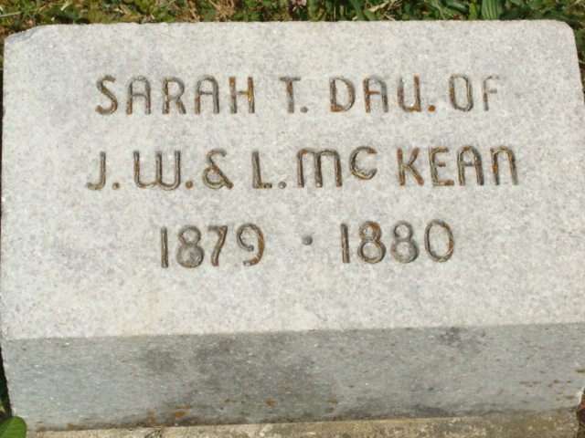
Photo by Alicia Kneuss

No obit found at this time

