James Madison McDaniel
October 10, 1834 – December 3, 1902

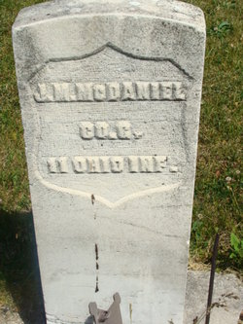
Photo by Alicia Kneuss
James Madison McDaniel, an old resident here, was found dead in bed yesterday morning at his home near the Chicago & Erie railway. He had been in good health and worked at cutting wood all day Tuesday. He returned home in the evening, ate a hearty supper and retired about nine o'clock, apparently as well as ever. He got up about midnight and said the storm kept him awake. Soon afterwards he went back to bed and soon fell asleep. His son, who slept with him, awoke at 7 o'clock yesterday morning and called his father, and receiving no answer, went to his side to arouse him and found him cold in death. Dr. D. D. Clark, acting coroner, was called and found that he had been dead several hours, the cause being heart trouble.
Mr. McDaniel was sixty-eight years, one month and twenty days old, having been born in Ohio, in November, 1834. He was a veteran of the Civil War and for some time has received a pension of twenty-four dollars per month.
The funeral services will be held tomorrow at the Beery Church.

Decatur Democrat, Adams County, IN
Thursday, December 4, 1902

*****
U.S. Civil War Soldiers, 1861-1865 No Image
Name: James M. McDaniel
Side: Union
Regiment State/Origin: Ohio
Regiment: 11th Regiment, Ohio Infantry; Company: G
Rank In: Private; Rank Out: Private
Alternate Name: James/McDaniel
Film Number: M552 roll 70
*****
U.S., Civil War Pension Index: General Index to Pension Files, 1861-1934
Name of soldier: James M McDaniel
Service: Co. G; 11 Ohio Infantry
Gender: Male
Place Filed: Indiana, USA
Relation to Head: Soldier
Spouse: Margaret E Mcdaniel
Filed as Invalid: July 8, 1871
Filed as Widow: Dec. 18, 1902
Remarks: D. - Dec. 3, 1902
*****
Indiana, Death Certificates, 1899-2011
Name: James Madison Mc Daniel
Gender: Male; Race: White; Age: 68; Marital status: Married
Birth Date: 10 Oct 1834; Birth Place: Ohio
Death Date: 3 Dec 1902; Death Place: Decatur, Adams, Indiana, USA
Spouse: Ellen Mc Daniel
Informant: John Reynolds; Decatur, Ind.
Burial: Dec. 3, 1902; Beery Cemetery

