Marie (Kettering) Lamons
January 7, 1920 – March 14, 1992
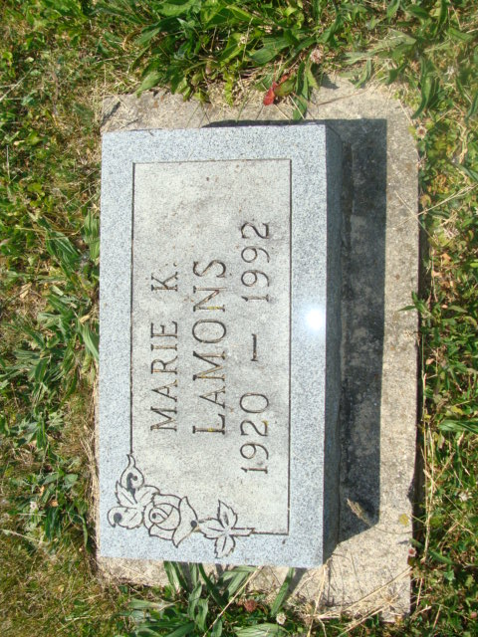
Photo by Alicia Kneuss

MARIE K. LAMONS, 72, of Decatur died Saturday at Ossian Health Care Center. The Kent, Ohio, native retired after 17 1/2 years as a bookkeeper for E.K. Williams Co., Fort Wayne. Surviving are her husband, Leroy R.; a son, Michael L. of Oveido, Fla.; stepsons, Charles W. of Bluffton and Harold A. of Granger; a sister, Sylvia Depew of Garrett; six grandchildren and seven great-grandchildren. Services are 1:30 p.m. tomorrow at the Zwick-Sefton & Jahn Funeral Home. Calling is 4 to 9 p.m. today and from noon to 1:30 p.m. tomorrow. Burial will be in Beery Cemetery near Decatur. Preferred memorials are gifts to New Life Fellowship Church, Monroe.

News-Sentinel, The (Fort Wayne, IN) - Tuesday, March 17, 1992

Contributed by Jane Edson

