Noah Johnston
August 3, 1841 – November 10, 1883

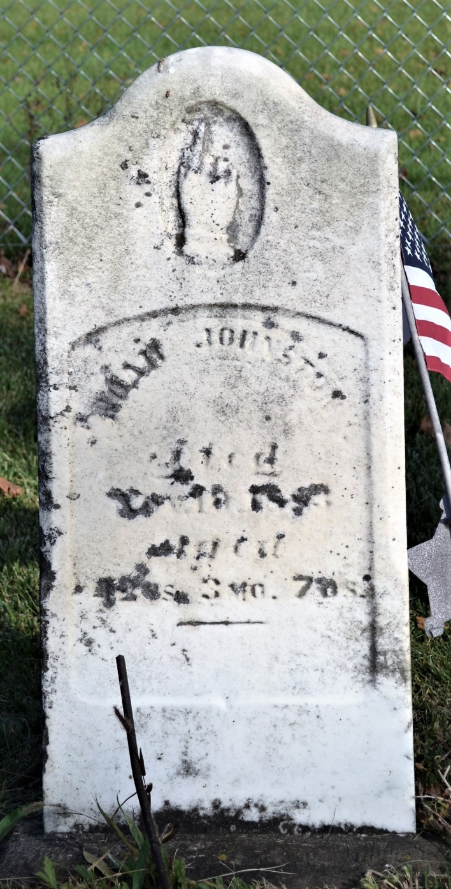
Photo by Colleen Sanders Broyles

No obit found at this time

