Jacob W. Johnston
October 23, 1853 – August 23, 1931

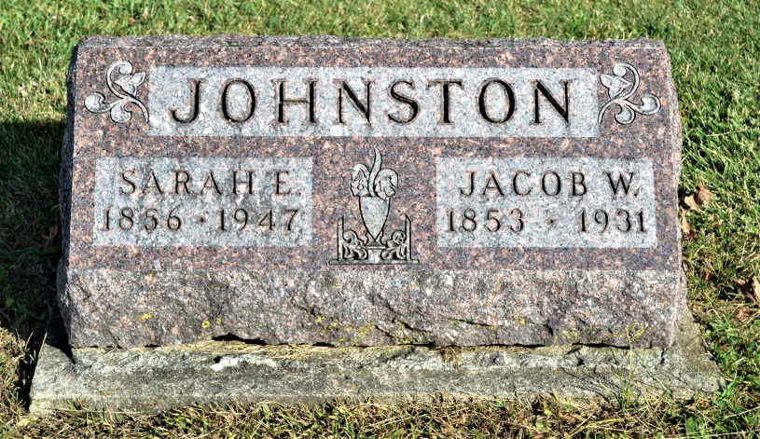
Photo by Colleen Sanders Broyles
Jacob W. Johnson
in the Indiana, Death Certificates, 1899-2011
Name: Jacob W. Johnson
Gender: Male
Race: White
Age: 77
Marital status: Married
Birth Date: 23 Oct 1853
Birth Place: Adams Co Ind.
Death Date: 23 Aug 1931
Death Place: Decatur, Adams, Indiana, USA
Father: Thomas Johnson
Mother: Eliza Ball
Spouse: Sarah E.
Informant: Sarah E. Johnston; Decatur, Ind.
Burial: Aug. 25, 1931; Beery Cemetery
*****

Jacob W. Johnston was born and has lived all his life on one farm in Adams County. He is one of the men who are in a position by experience to appreciate the assertion that "home keeping hearts are happiest," and it is a tribute to his steadfastness of character that he has been content to live in and witness the successive changes of one locality for over fifty years.
This farm where he was born and where he now lives is near Washington Church in section 18 of Washington Township, five miles southwest of Decatur. He was born there October 23, 1853, son of Thomas and Eliza (Ball) Johnston. His father, who was a native of Maryland, went with his parents to Tuscarawas County, Ohio, where he grew to manhood and where he married his first wife. Impelled by the desire for new land in a less densely populated section he came to Adams County in pioneer days and here entered a quarter section from the Government in section 18, Washington Township. Thomas Johnston did much of the heavy work of clearing and improving on that land, and its first crops were grown from his planting. His first wife died there and all their four children are now deceased. He married for his second wife Eliza Ball, daughter of James Ball. Thirteen children were born to the second marriage, and those still living are: Rebecca, widow of Charles F. Chaney of Plymouth, Indiana; Martha J., wife of George Christ of Richland Township; Abner S. of Kansas City; Barton B. of Linn County, Kansas; Rachel A., wife of Abe Stoneburner of Decatur; Miss Mary L. of Decatur.
Jacob W. Johnston as a boy attended district school near the old homestead, and at the same time developed his strength by the duties of the farm. Some years after reaching manhood on April 27, 1888, he married Miss Sarah E. Burkhead. She was born in Illinois but was reared and educated in the schools of Adams County, Indiana. Seven children have been born to their marriage: Mary A., wife of Dallas Grim; John F. of Fort Wayne, Indiana; and Ada L., wife of William Martin; Eliza, wife of Edward Arnold; Thomas V., of Decatur; Elmer D., unmarried and at home; and Anna P., wife of Roy Jahn, who is now in the United States army at Camp Taylor.
The Johnston family are members of the Methodist Episcopal Church in Washington Township and Mr. Johnston is one of the church trustees. He belongs to the Adams County Detective Association and in politics is a democrat. His farm consists of 100 acres that has produced probably fifty or sixty crops and is still fertile, productive, under a high state of cultivation and one of the best farms and finest homesteads in the county.

Standard History of Adams and Wells Counties, Indiana, Vol. II, John W. Tyndall & Orlo Ervin Lesh; Chicago: Lewis Publishing Co, 1918, p. 835-836.

