Mary Elizabeth Johnson
February 16, 1872 – November 30, 1902

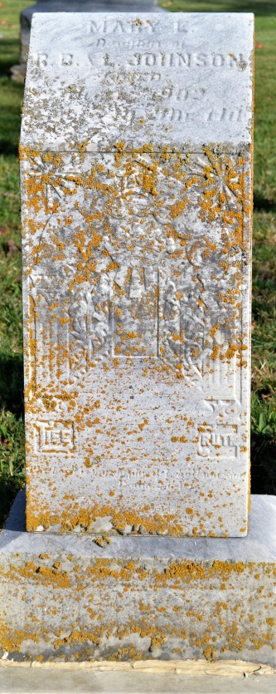
Photo by Colleen Sanders Broyles
Mary Elizabeth Johnson, a well-known young lady of Peterson, died Sunday afternoon after an illness of several months with consumption. She was popular in her home town and in this city also, she having lived here a few months.
The funeral services were held at the Beery Church yesterday morning.

Decatur Democrat (a weekly newspaper), Adams County, IN
Thursday, Dec. 4, 1902

Indiana, Death Certificates, 1899-2011
Name: Mary Elizabeth Johnson
Gender: Female; Race: White; Age: 30 years, 9 months, 14 days
Marital status: Single
Birth Date: 16 Feb 1872; Birth Place: Indiana
Death Date: 30 Nov 1902; Death Place: Kirkland, Adams, Indiana
Father: R B Johnson; Mother: Louiza Baker
Informant: Mrs. Louiza Johnson; Peterson, Ind.
Burial: Dec. 3, 1902; Beery Cemetery

