Linda S. (Drake) Hamrick
October 10, 1954 – November 11, 2017

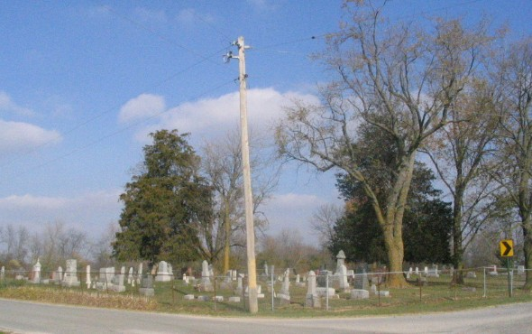
Photo by Barbara Baker Anderson

Linda S. Hamrick, 63, of Craigville, IN passed away on Saturday, November 11, 2017 at her residence. Linda was born on October 10, 1954 in Decatur, IN to the late Robert Drake and Claudia Vore. On January 6, 1974, Linda married Murlin “Skinny” Hamrick; he preceded her in death on May 15, 2017.
Linda is survived by her three sons, Shawn (Kendra) Hamrick of Berne, Adam (Trina) Hamrick of Bluffton and Shane Hamrick of Decatur; a daughter, Barbara Woolum of Craigville; a brother, John (Joyce) Drake of Decatur; 11 grandchildren.
A private family grave side service will be held at a later date at Beery Cemetery.
Memorials are to the Family and can be made through the funeral home.
Haggard-Sefton & Hirschy Funeral Home online obit (accessed 11/14/2017)

