Florence Good
May 31, 1897 – May 31, 1897

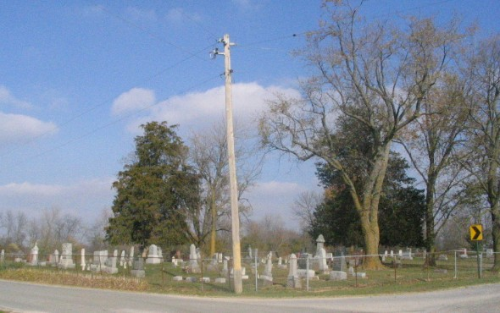
Photo by Barbara Baker Anderson

Indiana Births, 1880-1920 Name: Good
Good, ---; Father: Simon; Mother: Margret Parrish; County: Adams; Gender: Female; Birth Date: 31 May 1897
Reference: Adams County, Indiana Index to Birth Records 1882 - 1920 Inclusive Volume I Letters A - Z Inclusive; Book: H-5, Page: 27

